PROJECT REPORT
On
ExamAI — AI-Powered Exam Preparation over Teacher-Approved Material
Submitted by
PATEL DHAIRYA (IU2341230041)
KHATRI KESHAV (IU2341230068)
PATEL SWET (IU2341230111)
In fulfillment for the requirements of Software Group Project as a part of
BACHELOR OF TECHNOLOGY
In
COMPUTER SCIENCE AND ENGINEERING
INSTITUTE OF TECHNOLOGY AND ENGINEERING
INDUS UNIVERSITY CAMPUS, RANCHARDA, VIA-THALTEJ
AHMEDABAD-382115, GUJARAT, INDIA
WEB: www.indusuni.ac.in
NOV 2026

PROJECT REPORT
ON
ExamAI — AI-Powered Exam Preparation over Teacher-Approved Material
In the partial fulfillment of the requirement for the degree of
Bachelor of Technology
in
Computer Science and Engineering
PREPARED BY
PATEL DHAIRYA (IU2341230041)
KHATRI KESHAV (IU2341230068)
PATEL SWET (IU2341230111)
UNDER GUIDANCE OF
Internal Guide
Ms. Shreya Bhatt, Assistant Professor, Department of Computer Science and Engineering, IITE, Indus University, Ahmedabad
SUBMITTED TO
INSTITUTE OF TECHNOLOGY AND ENGINEERING
INDUS UNIVERSITY CAMPUS, RANCHARDA, VIA-THALTEJ
AHMEDABAD-382115, GUJARAT, INDIA
WEB: www.indusuni.ac.in
NOV 2026

INDUS INSTITUTE OF TECHNOLOGY AND ENGINEERING
COMPUTER SCIENCE & ENGINEERING
NOV 2026
CERTIFICATE
Date: __/10/2026
This is to certify that the Software Group Project work entitled “ExamAI — AI-Powered Exam Preparation over Teacher-Approved Material” has been carried out by Patel Dhairya, Khatri Keshav and Patel Swet under the guidance of Ms. Shreya Bhatt in partial fulfillment of the requirements for the Bachelor of Technology in Computer Science and Engineering (7th Semester) of Indus University, Ahmedabad during the academic year 2026.
______________________  Ms. Shreya Bhatt  Guide  Department of Computer Science And Engineering,  IITE, Indus University,  Ahmedabad. | ______________________  Dr. Kaushal Jani  Head of Department  Department of Computer Science And Engineering,  IITE, Indus University,  Ahmedabad. | ______________________  Prof. Zalak Vyas  Head of Department  Department of Computer Science And Engineering,  IITE, Indus University,  Ahmedabad.

CANDIDATE’S DECLARATION
We hereby declare that the Software Group Project report entitled “ExamAI — AI-Powered Exam Preparation over Teacher-Approved Material” is the result of our own work carried out under the guidance and supervision of Ms. Shreya Bhatt.
We further declare that, to the best of our knowledge, this report does not contain any part of the work that has been submitted previously for the award of any degree or diploma in this university or any other university, except where due acknowledgement and citation have been made.
___________________________________
Candidate’s Signature — PATEL DHAIRYA (IU2341230041)
___________________________________
Candidate’s Signature — KHATRI KESHAV (IU2341230068)
___________________________________
Candidate’s Signature — PATEL SWET (IU2341230111)
___________________________________
Guide: Ms. Shreya Bhatt, Assistant Professor, Department of Computer Science and Engineering, IITE, Indus University, Ahmedabad

Acknowledgement
As we move towards the successful completion of our Software Group Project in the 7th semester of the B.Tech program in Computer Science & Engineering, we would like to express our sincere gratitude to all those who supported and guided us throughout this journey.
We are especially thankful to our internal guide, Ms. Shreya Bhatt, Assistant Professor, Department of Computer Science and Engineering, for her constant guidance — from finalizing the project scope, through the system design and RAG architecture reviews, to the final report. Her feedback at every stage helped turn an initial idea into a complete, working system.
We are grateful to all the faculty members of Indus University, Ahmedabad, for their continuous support and encouragement. A special thanks to Mr. Jignesh Patel, who played a key role in helping us identify and define our project topic. We also sincerely thank Dr. Kaushal Jani and Prof. Zalak Vyas, Heads of the Department of Computer Science and Engineering, for creating an environment that encouraged independent, practical project work.
This experience has significantly enhanced our technical and collaborative skills, and we are truly thankful to everyone who contributed to this enriching learning opportunity.
- PATEL DHAIRYA (IU2341230041)
- KHATRI KESHAV (IU2341230068)
- PATEL SWET (IU2341230111)

ABSTRACT
ExamAI is a full-stack, AI-assisted exam-preparation platform that connects students with teacher-approved learning material. Students select an enrolled subject, choose which approved materials should scope a study session, ask questions, and receive answers grounded in retrieved passages with numbered citations that identify the teacher, the file, and the page or slide. Teachers upload PDF, PPTX and DOCX materials, monitor ingestion status, author quizzes manually or with AI assistance, publish one shared quiz per topic for the whole class, and review class performance through analytics. Students additionally generate personal flashcard decks from their selected materials.
The platform is implemented as a React frontend and a FastAPI backend. Supabase provides authentication, PostgreSQL storage and private file storage. A single metadata-filtered Qdrant collection stores embedded material chunks; Gemini provides structured language-model generation for chat answers, quiz questions and flashcards, guarded by schema-driven retries. Authorization is enforced in the service layer: teacher access follows subject membership, student access follows subject enrollment, and every retrieval is pre-validated so a student can never cite material from a subject they are not enrolled in.
The project was built incrementally over one academic semester, verified by 82 offline backend tests and 63 frontend tests. In conclusion, ExamAI demonstrates that retrieval-grounded study help, shared teacher-authored assessment, personal revision content and class-wide analytics can be combined into one coherent, role-aware system — closing the specific gaps identified in the literature survey in Chapter 2.

LIST OF FIGURES
Figure No | Title
Figure 7.1 | System architecture
Figure 7.2 | Class diagram
Figure 7.3 | Use-case diagram
Figure 7.4 | Sequence diagram — RAG chat
Figure 7.5 | Activity diagram — material ingestion
Figure 7.6.1 | Data flow diagram — Level 0
Figure 7.6.2 | Data flow diagram — Level 1
Figure 8.1 | Sign-in form (seeded login, no signup)
Figure 8.2 | Student dashboard — hero, quick stats, enrolled subjects
Figure 8.3 | Subject resources grouped by teacher
Figure 8.4 | RAG chat — scope panel, citations, grounded refusal
Figure 8.5 | Published quiz list with scores
Figure 8.6 | Quiz taking view
Figure 8.7 | Result card — grade, areas to review
Figure 8.8 | Question review — correct vs wrong
Figure 8.9 | Flashcard deck list with mastery progress
Figure 8.10 | Flip-study view
Figure 8.11 | Teacher materials with ingestion states
Figure 8.12 | Teacher quiz list — draft/published, manual/AI
Figure 8.13 | Per-quiz analytics — heatmap, distribution, weak topics
Figure 8.14 | Student progress roster with at-risk flags
Figure 8.15 | Teacher dashboard overview

LIST OF TABLES
Table No | Title
Table 2.3 | Existing systems vs ExamAI
Table 3.1 | Work breakdown structure
Table 3.2.5.1 | Time allocation
Table 3.3 | Risk management
Table 4.2 | Functional requirements
Table 4.4 | Non-functional requirements
Table 6.1 | Representative test cases

ABBREVIATIONS
Abbreviations used throughout this whole document for the ExamAI project are:
Abbreviation | Full Form
AI | Artificial Intelligence
API | Application Programming Interface
CRUD | Create, Read, Update, Delete
DFD | Data Flow Diagram
DOCX | Word Open XML Document
HTTP | HyperText Transfer Protocol
JSON | JavaScript Object Notation
JWT | JSON Web Token
LLM | Large Language Model
ORM | Object Relational Mapping
PDF | Portable Document Format
PPTX | PowerPoint Open XML Presentation
RAG | Retrieval-Augmented Generation
REST | Representational State Transfer
SQL | Structured Query Language
UI | User Interface
UX | User Experience
UUID | Universally Unique Identifier

TABLE OF CONTENTS
Right-click > Update Field to generate the Table of Contents.

1.1 Project Summary
ExamAI is a web application built to make exam preparation more trustworthy and less fragmented for students, while giving teachers control over the material that AI-assisted study is grounded in. Today a student preparing for an examination typically searches through several files, asks a general-purpose chatbot that cannot say where its answer came from, practices from quiz links that differ from student to student, and revises from self-made notes. A teacher, meanwhile, distributes material in one place, collects quiz responses in another, and interprets class performance largely by hand.
ExamAI brings these activities into a single role-aware platform. A student selects an enrolled subject, chooses which teacher-approved materials should scope a study session, asks questions, and receives answers with numbered citations that identify the teacher, the file, and the page or slide each claim comes from. The same student attempts the same published quiz as every classmate in the subject, receives per-question feedback with weak topics, and generates personal flashcard decks from selected material for revision. A teacher uploads PDF, PPTX and DOCX materials, monitors their processing status, authors quizzes manually or with AI assistance, publishes them for the class, and reviews performance through per-quiz analytics and cross-quiz student progress views.
The application is built using React for the frontend, FastAPI (Python) for the backend, PostgreSQL for relational data, Qdrant for vector retrieval, and Gemini for structured generation. Access control follows subject membership on both sides: teachers act through subject membership, students through subject enrollment.
1.2 Project Purpose
The purpose of ExamAI is to give students one reliable place to prepare for examinations from material their teachers actually approve — and to make every AI-generated answer traceable back to that material. An answer that cannot say which teacher's file and which page it came from leaves a student with no one to ask when in doubt. ExamAI treats attribution as a core requirement, not a cosmetic addition: each citation carries the teacher's name, the filename, and the source page or slide, so a confused student knows exactly who to contact. (Contacting the teacher remains out of scope; the system only surfaces who and what.)
For teachers, the purpose is complementary: a practical way to distribute approved material, create comparable assessments in which every student answers the same questions, and inspect class-wide progress instead of reconciling scattered quiz tools. Building it as one system, rather than four disconnected tools, keeps study activity, assessment, and analytics connected by the same data and authorization rules.
1.3 Project Scope
The system is capable of:
- Secure email/password login for provisioned users, with the role (student or teacher) derived from the backend profile.
- Subject dashboards: enrolled subjects for students, teaching subjects for teachers, with multi-teacher subjects supported.
- Teacher-owned material uploads (PDF, PPTX, DOCX, 25 MB limit) with processing / ready / failed status, retry, and deletion.
- Subject-scoped RAG chat over a per-session material selection, returning answers with numbered teacher/file/page citations.
- Manual and AI-assisted quiz authoring converging on the same question shape, with a draft → review → publish flow.
- Shared published quizzes: all students in a subject take the same quiz; server-side grading with per-question feedback and weak-topic detection.
- Student-owned flashcard deck generation from selected materials, with mastery tracking (new / learning / mastered).
- Teacher analytics: per-quiz views (accuracy heatmap, grade distribution, weak topics) and cross-quiz student progress (averages, completion, at-risk flags, drill-down).
The current version has a few known limits:
- It is a web application only — there is no mobile app yet.
- Users are provisioned by an explicit seed operation; there is no public signup, password reset, OAuth, or admin role.
- There is no in-app teacher–student messaging or broadcast.
- Student-generated graded quizzes are deferred as explicit v2 scope, to protect the fairness of shared assessment.
- Retrieval is dense-vector only; hybrid dense-plus-sparse search is a flagged future enhancement, not part of this delivery.
- The live behaviour of generation features depends on the configured Gemini model, quota and billing, which must be verified per deployment (the configured default is `gemini-2.5-flash`).
1.4 Objectives
1.4.1 Main Objectives
- To build a single role-aware platform for AI-assisted exam preparation.
- To ground every study answer in teacher-approved material and attribute each claim to its teacher, file, and page or slide.
- To keep assessment fair by publishing one shared quiz per topic for all students in a subject.
- To return feedback beyond a total score: per-question results and weak-topic detection.
- To let students generate personal revision decks from their own selected materials.
- To give teachers class-wide comparability through per-quiz analytics and cross-quiz progress views.
1.4.2 Secondary Objectives
- To enforce subject membership and role authorization in service-layer logic, not only in route declarations.
- To preserve source metadata end to end — parsing, chunking, embedding, retrieval, citation — so attribution never depends on a per-request database lookup.
- To handle structured model-output failures through schema-driven, error-aware retries.
- To keep the ingestion pipeline safe under concurrent upload, retry, and delete operations.
- To keep the codebase organized (thin routes, logic in services, schemas separate from models) so new features do not require rewriting old ones.
1.5 Technology and Literature Overview
1.5.1 Retrieval-Augmented Generation
Retrieval-augmented generation is an approach that combines information retrieval with language generation. Instead of asking a model to answer from its general training alone, the system first retrieves relevant passages from a controlled collection and supplies them as context, so the answer is grounded in identifiable sources. ExamAI uses this approach for subject chat and for AI-assisted quiz generation: retrieval is constrained by subject enrollment and the student's selected materials before the vector database is ever queried.
1.5.2 Vector Search and Embeddings
An embedding represents text as a numerical vector, so that semantically related passages can be compared by distance. ExamAI embeds material chunks locally with the `all-MiniLM-L6-v2` sentence model and stores them in a single Qdrant collection shared across all subjects and materials. Each stored point carries payload metadata — subject, material, teacher, filename, teacher name, and a stable source locator (page, slide, or paragraph number) — which makes metadata-filtered retrieval and citation attribution possible without per-chunk database round-trips.
1.5.3 Programming Languages
Programming languages provide the instructions a computer executes to build software systems. ExamAI's backend and ingestion pipeline are written in Python, and its frontend is written in JavaScript (as React/JSX). Python was chosen for the backend because the AI ecosystem — embedding libraries, document parsers, and model clients — is strongest there; JavaScript/React was chosen for the frontend because the interface is a dynamic, stateful study workspace.
1.5.4 Libraries and Tools
The project uses several important libraries:
- React.js — used for building the interactive study interface (dashboards, chat, quiz taking, flashcards, analytics).
- Vite — provides fast builds and the development server for the frontend.
- FastAPI — the Python web framework serving the HTTP API, with automatic request validation and interactive API documentation.
- SQLAlchemy + Alembic — database access with defined schema, plus versioned migrations.
- Pydantic — validates API shapes and doubles as the structured-output contract for model generation.
- Supabase — provides authentication, PostgreSQL hosting, and private file storage.
- Qdrant client — metadata-filtered vector search over embedded material chunks.
- Zustand, React Router, Tailwind CSS — client state, navigation, and styling.
1.5.5 Literature Overview
Digital learning platforms have been studied and built extensively: learning-management systems organize content and grades, MOOC platforms deliver courses at scale, flashcard tools support spaced revision, and general-purpose chatbots answer arbitrary questions fluently. What the survey in Chapter 2 shows is that none of the widely used options combine the four properties an examination setting needs — teacher-approved sources, answers attributed to a teacher and page, one shared assessment for the whole class, and class-wide analytics — in a single system. ExamAI is built specifically to close that gap, as detailed in Chapter 2.
1.6 Synopsis
ExamAI is a web-based exam-preparation platform in which students study from teacher-approved materials through attributable RAG chat, take the same teacher-published quizzes as their classmates, revise with self-generated flashcards, and teachers monitor class performance through analytics. It is built with React, FastAPI, PostgreSQL, Qdrant, and Gemini, with authorization enforced at the service layer and source metadata preserved from ingestion to citation. The following chapters present the literature survey, project management, requirements, analysis, testing, design, results, limitations, and conclusion of the project.

2.1 Introduction of Survey
Before building ExamAI, widely used learning platforms and study tools were studied to understand what they already do well and where they fall short for examination preparation. The review focused on five popular, representative options that students and teachers actually use: Moodle (the most widely deployed open-source learning-management system), Google Classroom (the most widely used lightweight classroom platform), Quizlet (the most popular flashcard-based revision tool), general-purpose LLM chatbots such as ChatGPT (what students most commonly ask study questions today), and NotebookLM (Google's retrieval-grounded study assistant over user-supplied sources — the closest existing product to our approach).
The comparison was deliberately operational rather than theoretical: it asks what each system does about content ownership, answer traceability, assessment comparability, feedback, analytics, and access control — the six properties Section 1.5.5 identifies as necessary in an examination setting.
2.2 Why Survey?
A survey of existing platforms is useful because it shows what students and teachers can already do elsewhere, so a new project does not simply repeat what already exists. It also exposes real gaps that a new system can be built specifically to close, instead of guessing what users might need. For ExamAI, the survey served three concrete purposes. First, it confirmed that content management (Moodle, Classroom) and revision tools (Quizlet) exist but are disconnected from AI-grounded question answering. Second, it confirmed that students already use generic chatbots for study help — but those answers carry no source attribution, which is precisely the trust problem ExamAI addresses. Third, it positioned the closest alternative, NotebookLM, and showed where a classroom system must go further: teacher ownership, shared assessment, and class analytics, none of which a personal study assistant provides.
2.3 Existing System vs Proposed System
Sr. No. | Aspect | Existing Systems | ExamAI (Proposed)
1 | Source control | Moodle / Classroom store teacher files, but AI answers (ChatGPT) are disconnected from them; NotebookLM grounds answers only in the student's own uploads | Teacher-owned, subject-scoped, status-checked materials are the *only* retrieval corpus
2 | Answer traceability | ChatGPT answers carry no source; Classroom/Moodle have no QA at all; NotebookLM cites the student's documents, not a teacher | Every answer carries numbered citations with teacher name, filename, and page/slide locator
3 | Assessment fairness | Quizlet/Forms-style quizzes are typically per-link and incomparable across a class | One published quiz per topic for all students in the subject, enabling class-wide comparison
4 | Feedback depth | Scores usually stop at a total; weak-topic analysis is absent | Server-side grading returns per-question feedback plus weak-topic detection per attempt
5 | Teacher insight | Scattered gradebooks (Classroom), or nothing (chatbots, Quizlet) | Dedicated per-quiz analytics (heatmap, grade distribution) plus cross-quiz student progress with at-risk flags
6 | Access control | Coarse roles; students can paste any content into a chatbot | Service-layer membership checks: enrollment for students, subject membership for teachers, per-request material validation

Table 2.3: Existing systems vs ExamAI.
Three gaps appeared consistently across all five options studied:
- **Attribution gap.** The tools students actually ask questions of (generic chatbots) cannot say which teacher's file and which page an answer came from. The tools that organize teacher files (Moodle, Classroom) cannot answer questions at all.
- **Comparability gap.** Revision and quiz tools are built around individual practice links. Nothing guarantees that every student in a class answers the same questions, so teachers cannot compare performance fairly.
- **Oversight gap.** No surveyed option connects study help, assessment, and class-wide analytics through one authorization model. Teachers either get a gradebook without study context, or study tools without any teacher visibility.
ExamAI is built directly around closing these three gaps: teacher-owned retrieval with teacher-attributed citations, shared published quizzes, and analytics fed by the same attempts — all guarded by subject membership.

3.1 Project Planning Objectives
- Define clear goals — what the platform must do for students and for teachers — before writing any code.
- Gather requirements from the literature survey, fixing the teacher-owned / shared-assessment / attributable-answer boundaries early.
- Design the system — data model, service boundaries, and API contracts — before building features on top of them.
- Build in dependency order — authentication and data access first, then materials, then ingestion, then retrieval, then quizzes and flashcards, then analytics — so each layer can be checked before the next is built on it.
- Validate risky integrations early (vector retrieval, structured model output, concurrent ingestion) behind service boundaries.
- Test continuously — offline backend and frontend suites run throughout, not only at the end.
- Keep a stable, working build ahead of every review milestone, deferring explicit v2 scope rather than destabilizing the core.
3.2 Project Scheduling
3.2.1 Basic Principle
The project was built in layers, one on top of the other: authentication and the relational data model first, then subject and material management, then the ingestion pipeline, then RAG chat, then quizzes and flashcards, and finally analytics and hardening. Each layer was verified on its own — for example, retrieval filtering was tested against seeded data before any generation feature consumed it — so problems were caught early, one layer at a time.
3.2.2 Compartmentalization
The system was split into clear, separate modules so each part could be built and tested on its own: a data layer (users, subjects, memberships, materials, quizzes, attempts, decks), a backend service layer (ingestion, retrieval, generation, grading, analytics), an API layer of thin route handlers, and a frontend layer (pages, stores, API client). The Pydantic schemas shared between the API and the model-output contracts act as the agreed interfaces between modules. Splitting the work this way meant a bug in one module rarely affected the others, and responsibilities could be divided among team members along module lines (Section 3.2.4).
3.2.3 Work Breakdown Structure
Phase | Primary work | Main outcome
0 — Foundations | Authentication, schema, migrations, project conventions | Seeded login with role derivation; versioned data model
1 — Subject & material access | Roles, enrollment, teacher-owned material management | Membership-gated subject views; upload with status tracking
2 — Ingestion | PDF/PPTX/DOCX parsing, chunking, embeddings, Qdrant upserts | `processing` → `ready` / `failed` pipeline with retry and safe delete
3 — RAG chat | Filtered retrieval, citation mapping, structured generation | Attributable answers scoped to per-session material selection
4 — Quizzes | Manual + AI-assisted authoring, publish flow, server-side grading | Shared published quizzes with feedback and weak topics
5 — Flashcards | Student-owned deck generation, mastery tracking | Personal revision decks from selected materials
6 — Analytics & performance | Per-quiz and cross-quiz read models; frontend optimization | Teacher dashboards; route splitting, caching, prefetch behaviour
7 — Hardening | Auth hardening, concurrency guards, test suites, cleanup | 82 offline backend tests; 63 frontend tests; audit fixes

Table 3.1: Work breakdown structure.
3.2.4 Project Organization
- **Internal Guide (Ms. Shreya Bhatt, Assistant Professor, CSE):** guides and reviews the project — scope approval, design and RAG-architecture feedback, milestone reviews, and report evaluation.
- **Patel Swet (IU2341230111) — core development:** system architecture, backend services and integration, AI/RAG pipeline (ingestion, retrieval, citations, generation, retries), data model and API contracts, and overall technical integration.
- **Khatri Keshav (IU2341230068) — frontend support:** study and dashboard interface work — pages, components, loading/empty/error states, and client-side presentation behaviour.
- **Patel Dhairya (IU2341230041) — backend support:** supporting backend functionality outside the core AI/RAG implementation — route/handler assistance, validation, and service-level support tasks.
- **End users:** students (study, quizzes, revision) and teachers (materials, assessments, analytics), whose needs define acceptance.
This allocation reflects the work actually performed: the core AI/RAG architecture, retrieval pipeline, and system integration were built by Swet; Keshav and Dhairya hold contained, viva-explainable responsibilities in the frontend and supporting backend respectively.
3.2.5 Timeline Chart
3.2.5.1 Time Allocation
Development ran over fourteen weeks, from the last week of July 2026 to the last week of October 2026 (repository history: first commit 24 Jul 2026), ahead of the November 2026 submission.
Phase | Duration | Description
Requirement analysis | 2 weeks (24 Jul – 6 Aug) | Survey of existing platforms (Chapter 2), scope and role definition.
System design | 2 weeks (7 – 20 Aug) | Data model, service boundaries, API contracts, UI layout.
Development | 6 weeks (21 Aug – 1 Oct) | Foundations → materials → ingestion → RAG chat → quizzes → flashcards → analytics, in dependency order.
Testing | 2 weeks (2 – 15 Oct) | Offline backend suite, frontend suite, manual end-to-end passes, bug fixes.
Hardening & documentation | 2 weeks (16 – 29 Oct) | Auth/concurrency review, cleanup, report writing, demo preparation.

Table 3.2.5.1: Time allocation.
3.3 Risk Management
Risk | Description | Mitigation Strategy
LLM model/quota changes | Generation features depend on a live model name, quota and billing. | Verify the live model early per deployment; schema-first prompts with error-aware retries so failures are structured, not silent.
Incorrect retrieval scope | Answers could cite material from a subject the student is not enrolled in. | Validate every material ID in Postgres before querying Qdrant; filter by both subject and material IDs (defence in depth).
Concurrent ingestion | Simultaneous upload / retry / delete could revive deleted rows or corrupt status. | Per-material locks, row-level guards, and version-safe conditional status updates.
Unclear role boundaries | Students reaching teacher functions or other subjects' content. | Service-layer membership checks on every subject-scoped operation; 403 (not 404) for unenrolled access.
Slow external services | Embedding, vector DB, or model latency hurting responsiveness. | Blocking work off the event loop; bounded caching and request deduplication on the client.
Scope creep | Personal quizzes, messaging, mobile apps delaying the core. | Explicit in-scope / future-scope split from Section 1.3, enforced at planning.
Time constraints | Any phase overrunning into review milestones. | Stable-build-ahead-of-review rule; risky integrations isolated behind service boundaries.

Table 3.3: Risk management.

4.1 User Characteristics
ExamAI has two kinds of users. **Students** can view enrolled subjects, scope study sessions to approved materials, ask questions, attempt published quizzes, review feedback, and generate and study flashcards. **Teachers** can manage subject materials (upload, monitor, retry, delete), author and publish quizzes manually or with AI assistance, and inspect quiz analytics and student progress. No special technical knowledge is needed — the interface is designed to be usable by anyone comfortable browsing a normal website, and no user is assumed to understand vector search or language-model operation.
4.2 Functional Requirement
ID | Requirement
FR-01 | The system shall authenticate a provisioned user with email and password and derive the role from the backend profile.
FR-02 | The system shall allow teachers to upload PDF, PPTX and DOCX materials for a subject, within the configured size limit.
FR-03 | The system shall process uploaded material and expose processing, ready, and failed status with retry and delete.
FR-04 | The system shall allow enrolled students to select ready materials to scope a study session.
FR-05 | The system shall return RAG answers with numbered citations identifying teacher, file, and source location.
FR-06 | The system shall allow teachers to create manual or AI-assisted quiz drafts in a common question shape.
FR-07 | The system shall require teacher publication before a quiz becomes available to students.
FR-08 | The system shall grade attempts on the server and return per-question feedback with weak topics.
FR-09 | The system shall generate personal flashcard decks from student-selected material, with mastery tracking.
FR-10 | The system shall provide per-quiz analytics and cross-quiz student progress views to teachers.

Table 4.2: Functional requirements.
4.3 Activity and Proposed System
A typical student activity begins with login and subject selection. The student opens the material-scope panel, chooses which ready materials should ground the session, and asks a question; the system returns an answer whose numbered citations identify the teacher and file behind each claim. The student may then attempt a published quiz under its time limit, review per-question feedback and weak topics, and generate a flashcard deck from the same or another material selection for revision.
A typical teacher activity begins with subject access, continues through material upload and ingestion monitoring, then quiz authoring — written manually or drafted by the AI from ready material and edited — followed by publication and analytics review. AI-generated quizzes always remain drafts until a teacher reviews and publishes them, keeping the teacher, not the model, responsible for assessment content. Saving personal study state is the student's domain; publishing shared assessment is the teacher's; the system never mixes the two.
4.4 Non Functional Requirement
Category | Requirement
Security | Role and subject-membership authorization enforced in services; access tokens kept in memory, refresh via HttpOnly cookie; CORS allow-list.
Reliability | Malformed model output, failed ingestion, retry/delete races, and concurrent operations handled without corrupting state.
Performance | Blocking parser/embedding work kept off the event loop; frontend uses route splitting, bounded caching, request deduplication, and stale-response protection.
Maintainability | Thin routes, schemas separate from ORM models, business logic in services; shared contracts via API envelopes.
Usability | Loading, empty, failure, and success states throughout; the active material scope always visible to the student.
Traceability | Every citation retains teacher, file, and source-location metadata from ingestion to answer.

Table 4.4: Non-functional requirements.
4.5 Hardware and Software Requirement
**Hardware Requirement.** As a web application, ExamAI needs no special hardware — any device that can run a modern browser can use it.
- Processor: any modern dual-core processor or above.
- RAM: 4 GB or more (8 GB recommended for local backend development with local embeddings).
- Internet connection: required to reach the API and its managed services.
- Input/Output: a screen with keyboard/mouse or touchscreen.
**Software Requirement.**
Layer | Technology / version (as used in this project)
Frontend | React 19, Vite 8, React Router 7, Zustand 5, Tailwind CSS 4
Backend | Python 3.14, FastAPI, Uvicorn, SQLAlchemy 2 + Alembic, Pydantic 2
AI / retrieval | sentence-transformers (`all-MiniLM-L6-v2`), qdrant-client ≥ 1.16, Gemini (`gemini-2.5-flash` configured default — verify per deployment)
Data & files | Supabase Postgres + Auth + private Storage
Tooling | Git & GitHub; FastAPI Swagger UI (`/docs`); pytest (82 backend tests); Vitest + Testing Library (63 frontend tests)

**Server Hosting Requirement.** The system is developed and verified as a local prototype and is deployment-ready: the FastAPI backend runs under Uvicorn, the frontend builds to static assets via Vite, and data, authentication, and file storage target managed Supabase (Postgres) with vector search on Qdrant Cloud. The reference production layout is Render.com (backend API) + static frontend hosting + managed Supabase and Qdrant services. The application has not yet been deployed online; deployment remains planned future work.

5.1 Study of Current System
The conventional exam-preparation workflow is distributed across unconnected tools. A student reads lecture files locally, searches the web or asks a general chatbot for explanations, practices from whatever quiz links are shared, and revises from personal notes. A teacher distributes material in one location (classroom drive, LMS page), collects quiz responses in another (forms, quiz links), and manually interprets performance. Study activity and assessment share no data: what a student asked about yesterday has no connection to what they are tested on today, and what a class got wrong has no automatic path back to the material that should be re-studied.
5.2 Problems in Current System
- Fragmented sources — explanations live in files, chatbots, and web pages with no single approved corpus.
- Unattributed answers — chatbot responses carry no teacher, file, or page reference, so doubts cannot be resolved with the right teacher.
- No access semantics — copied files and shared links bypass any notion of enrollment or ownership.
- Incomparable assessment — per-link quizzes differ between students, so class-wide comparison is unreliable.
- Shallow feedback — a total score says what was achieved, not which topics are weak.
- Manual revision overhead — flashcards and summaries must be built entirely by hand.
5.3 Requirement of New System
- One approved corpus per subject: teacher-owned, status-checked materials as the only retrieval ground.
- Source-aware answers: every claim attributable to teacher, file, and page/slide.
- Subject-level authorization: enrollment for students, membership for teachers, validated per request.
- Shared assessment: one published quiz per topic for the whole class.
- Feedback with diagnosis: per-question results and weak-topic detection.
- Personal revision content: student-generated decks from selected materials.
- Connected analytics: per-quiz and cross-quiz teacher views fed by the same attempts.
5.4 Process Model
ExamAI was built using an incremental development model: requirements were converted into data and service contracts, then each phase delivered a vertical slice across backend and frontend, tested offline where possible, and reviewed before the next slice began. External-service risks (model availability, vector-database behaviour, embedding cost) were isolated behind utility and service boundaries, so the core logic never depends directly on a vendor response shape. Cleanup and hardening passes followed once features stabilized, rather than interrupting feature development.
5.5 Feasibility Study
5.5.1 Technical Feasibility
The system is technically feasible because each required function maps to a mature, well-documented technology: FastAPI and React for the web boundary, PostgreSQL for relational authorization and assessment data, Qdrant for filtered vector retrieval, and Gemini for structured generation validated by Pydantic schemas. All are available as free or development-tier services at this project's scale, so no specialized infrastructure is needed. The principal uncertainty — live model availability and quota — is contained by configuration and error-aware generation paths.
5.5.2 Operational Feasibility
The workflows match the real responsibilities of the two roles: students see only approved material and their own progress; teachers retain control over source files and shared quizzes, including mandatory review of AI-drafted questions. Most study features need no training beyond normal web use. The system is therefore operationally suitable as a classroom prototype; institutional deployment would additionally require onboarding, support, backup, and privacy procedures.
5.5.3 Economical Feasibility
The prototype uses open-source frameworks and managed free or development-tier services. Local embeddings avoid repeated remote-embedding cost. The variable costs are hosted database, vector storage, file storage, and model usage — each replaceable or scalable independently, since no business logic is locked to a vendor SDK beyond thin utility wrappers.
5.5.4 Schedule Feasibility
The phased plan in Section 3.2.3 is schedule-feasible because it keeps a stable build ahead of review milestones and explicitly defers non-essential features (personal graded quizzes, messaging, mobile clients, hybrid retrieval). Building in dependency order meant later phases consumed stable contracts instead of waiting on open design decisions.
5.6 Features of New System
- Secure login with backend-derived roles; enrollment- and membership-gated subject access.
- Teacher-owned material management: upload, processing/ready/failed states, retry, deletion, multi-teacher visibility.
- Document ingestion for PDF, PPTX, and DOCX with format-aware chunking and source-locator preservation.
- Attributable RAG chat over per-session material selection, with numbered teacher/file/page citations.
- Shared quizzes: manual and AI-assisted authoring, draft → publish flow, server-side grading with weak topics.
- Personal flashcard generation with mastery-state tracking.
- Teacher analytics: question-accuracy heatmap, grade distribution, weak topics per quiz; averages, completion, at-risk flags, and drill-down across quizzes.
- Frontend performance safeguards: code-split routes, bounded caching, request deduplication, stale-response protection.

6.1 Black-Box Testing
The following black-box tests check that each feature behaves correctly from a user's point of view, without looking at the underlying code:
- Login Testing — a provisioned student or teacher can log in with the correct email and password and receives the correct role.
- Invalid Login Testing — wrong credentials are rejected with an appropriate error.
- Unauthorized Subject Testing — a student requesting another subject's materials receives a forbidden response, not data.
- Material Upload Testing — a teacher upload of a supported file type within the size limit is accepted and enters processing.
- Invalid Upload Testing — an unsupported file type or oversized file is rejected with a clear message and never ingested.
- Chat Scope Testing — a question scoped to authorized, ready materials returns an answer with numbered teacher/file citations.
- Cross-Subject Chat Testing — a request naming a material ID from another subject is refused before any vector query runs.
- Quiz Publication Testing — a draft quiz is invisible to students until the teacher publishes it.
- Attempt Testing — submitting an attempt returns a score with per-question feedback and weak topics; duplicate submission does not duplicate the score.
- Flashcard Testing — deck generation from selected materials produces reviewable cards with mastery states.
- Analytics Testing — per-quiz and cross-quiz views return their separate read models only to the subject's teachers.
6.2 White-Box Testing
The following checks were made against the internal logic of the system:
- Input Validation Logic — Pydantic schemas reject malformed input (bad identifiers, out-of-range values, wrong file types) before it reaches services or storage.
- Authorization Logic — service-layer membership checks (enrollment for students, subject membership for teachers) verified for both allowed and denied paths.
- Retrieval Filter Logic — the Qdrant filter always carries both subject and material constraints built from Postgres-validated IDs.
- Citation Mapping Logic — each `[n]` marker in generated text resolves to the payload metadata (teacher, filename, locator) of the retrieved chunk.
- Structured-Output Retry Logic — malformed model JSON (code fences, trailing prose, wrong field types) triggers an error-aware retry carrying the verbatim error, the bad response, and the schema.
- Grading Logic — server-side scoring, per-question correctness, and weak-topic derivation checked against hand-computed attempts.
- Ingestion State Logic — status transitions (processing → ready / failed), retry from failure, and version-safe updates under concurrent operations.
- API Contract Logic — every endpoint exercised with valid and invalid payloads through the interactive API documentation; standardized response envelopes verified.
6.3 Test Cases
Test ID | Test Case | Input | Expected Result
TC1 | Valid student login | Correct provisioned email + password | Session established, student role returned
TC2 | Student requests another subject's material | Subject ID with no enrollment row | Forbidden response
TC3 | Teacher uploads unsupported file | Executable / disallowed extension | Validation error; file not ingested
TC4 | Student selects unrelated material ID | Material ID from another subject | Authorization fails before vector query
TC5 | RAG answer generated | Question + authorized ready scope | Answer with numbered citations carrying teacher and filename
TC6 | Malformed model JSON | Forced bad structured output | Error-aware retry validates the corrected output
TC7 | Student submits quiz twice | Same attempt submitted again | Idempotent; score not duplicated
TC8 | Teacher reads analytics | Per-quiz and progress requests | Separate correct read models returned
TC9 | Frontend stale response | Slow earlier request resolving last | Older response does not overwrite current state

Table 6.1: Representative test cases — all passing.
The backend suite (82 tests across smoke, phase, and review-fix files) runs fully offline in under a second; the frontend suite (63 tests across routes, stores, API client, and components) runs under Vitest. Integration with hosted services (Supabase, Qdrant, Gemini) remains environment-dependent and is covered by manual end-to-end passes rather than automated tests.

7.1 System Architecture
The architecture has a presentation layer, an API and service layer, a relational data layer, a vector retrieval layer, and external AI and storage services. The frontend calls the FastAPI API directly. Route handlers stay thin: they authenticate the request and delegate to services. Services enforce membership, read or write relational state, and call ingestion, retrieval, generation, grading, or analytics components as needed.
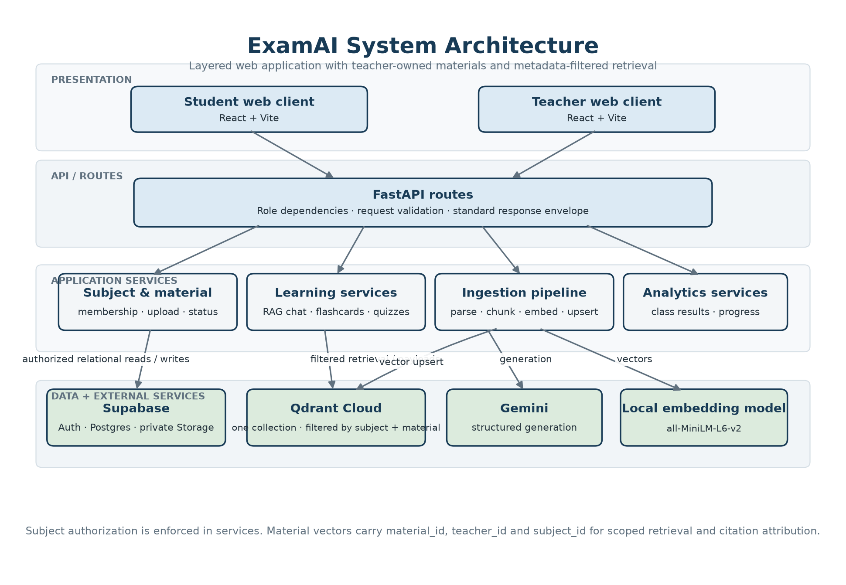
Figure 7.1: System architecture
Layer | Responsibilities
Frontend | Pages, routing, stores, API client, caching, loading and error states
API | Authentication, request validation, standardized response envelope, request IDs
Services | Materials, ingestion, RAG chat, quizzes, flashcards, analytics; all authorization
Relational data | Users, subjects, memberships, materials, quizzes, attempts, decks
Vector + AI | Qdrant filtered retrieval, Gemini structured generation, local embeddings
Storage | Private teacher material files, application configuration

7.2 Class Diagram
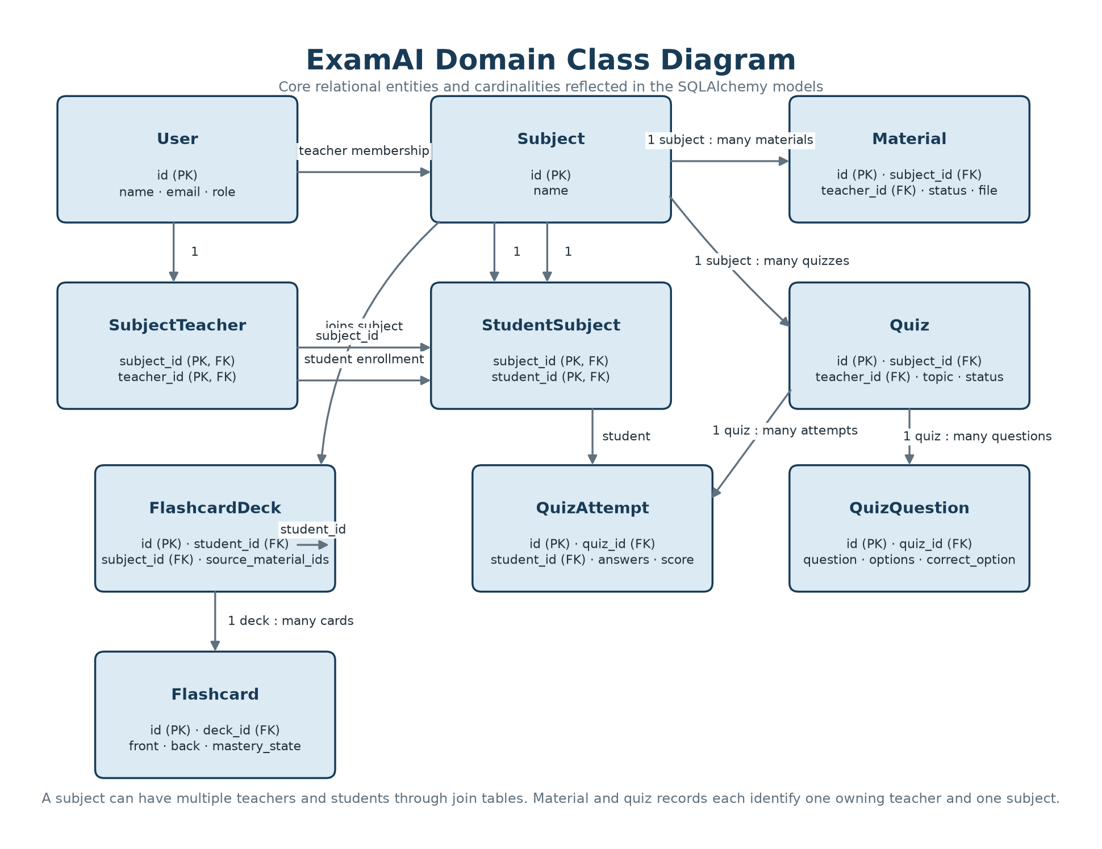
Figure 7.2: Class diagram
The domain centres on Subject: teachers join it through membership, students through enrollment; materials and quizzes belong to exactly one subject and one teacher; attempts belong to one student and one quiz; decks belong to one student and record the source material identifiers used at generation time.
7.3 Use-Case Diagram
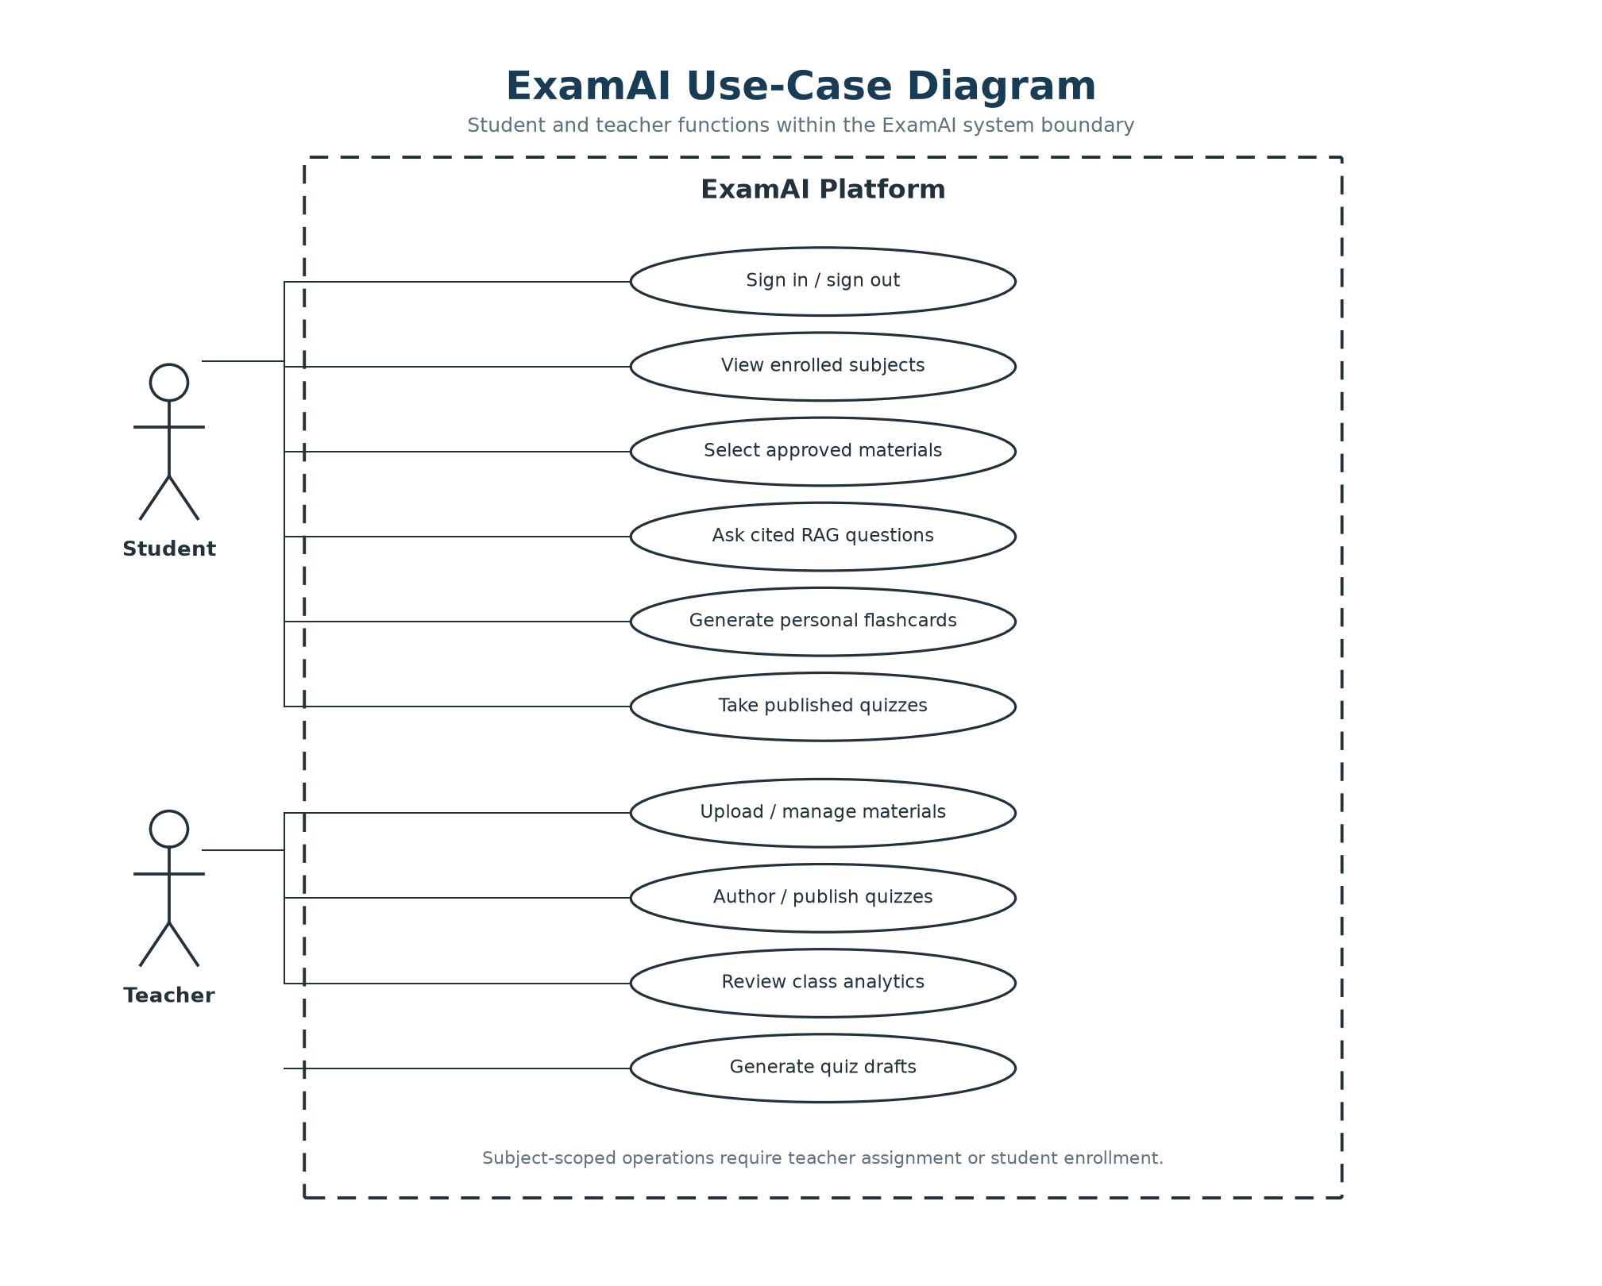
Figure 7.3: Use-case diagram
Both roles authenticate through the same sign-in flow. Subject-scoped requests are authorized against the caller’s teacher assignment or student enrollment before protected data is returned or changed.
7.4 Sequence Diagram
The sequence below shows one representative interaction — RAG chat — step by step, since this flow touches every layer of the system in a single user action: the frontend sends subject, selected material identifiers, and a question; the service checks enrollment and validates every identifier in Postgres; the question is embedded; Qdrant is queried with subject-plus-material filters; Gemini receives numbered context; the response is parsed; citation markers are mapped to payload metadata; and the API returns answer text plus citations.
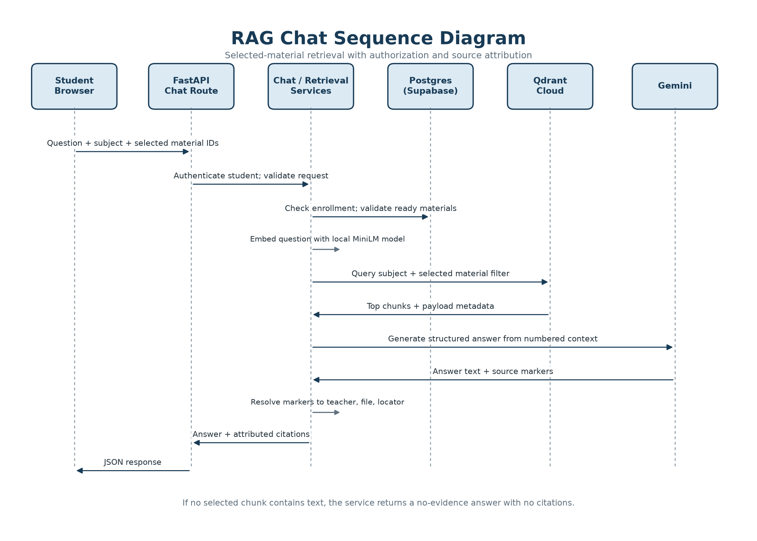
Figure 7.4: RAG chat sequence
7.5 Activity Diagram
Material ingestion begins with a teacher upload. The service validates type and size, stores the private file, creates a processing record, parses the document, normalizes text and metadata, chunks content with format-aware windows, creates embeddings, upserts points in batches, and marks the material ready. A failure marks the material failed and exposes retry; deletion removes both the relational record and its vectors. Version-safe status updates prevent stale work from reviving deleted records.
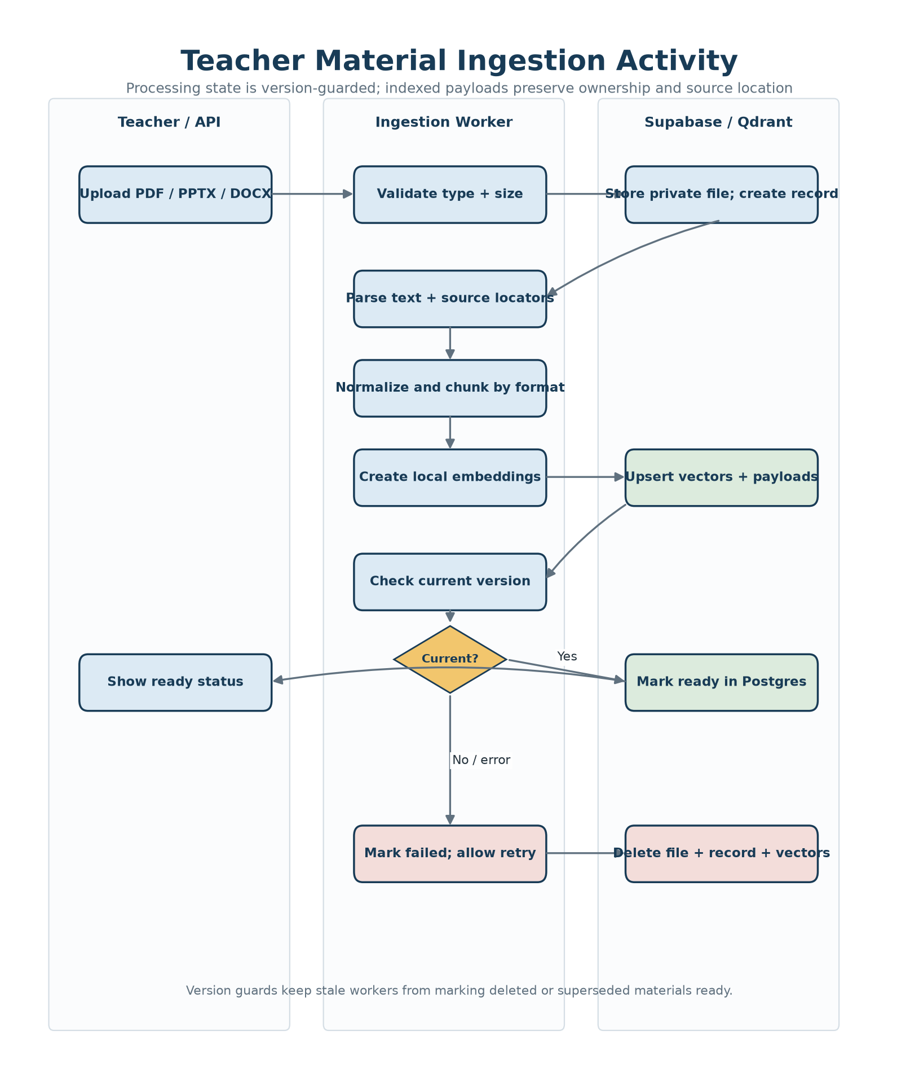
Figure 7.5: Material ingestion activity
7.6 Data Flow Diagram (DFD)
7.6.1 Level 0 DFD
At the highest level, students and teachers interact with ExamAI. ExamAI communicates with Supabase for identity, relational data, and file storage; with Qdrant for vector retrieval; and with Gemini for structured generation. The system returns study answers, assessments, feedback, decks, and analytics.
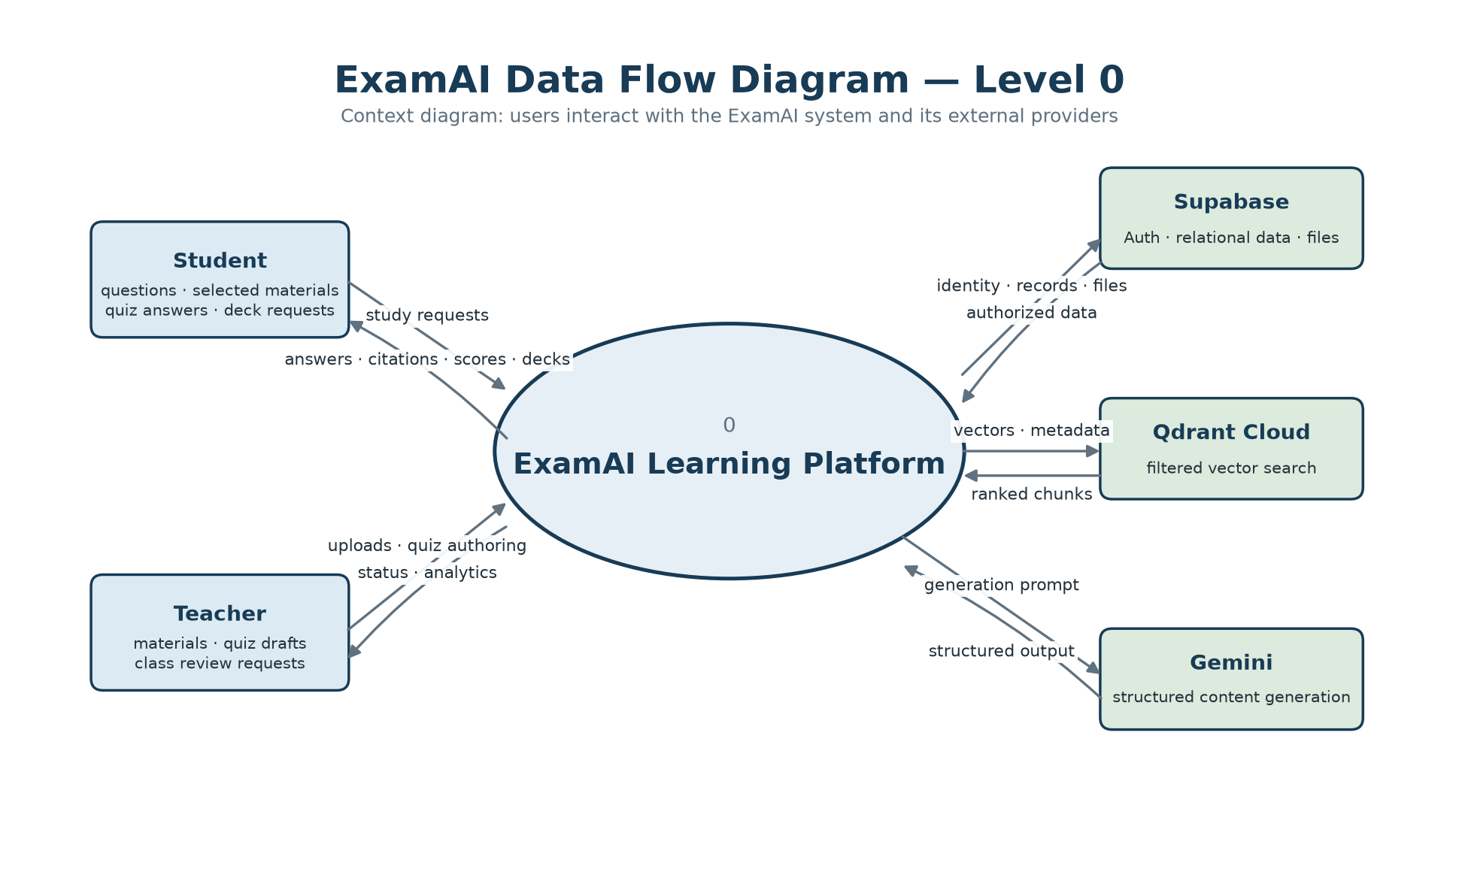
Figure 7.6.1: Level 0 DFD
7.6.2 Level 1 DFD
The level-one flow separates authentication, subject access, material ingestion, RAG chat, quiz management, flashcard generation, and analytics. Authorization is checked by the services handling subject-scoped requests. During ingestion, material, teacher, and subject identifiers are stored in each Qdrant payload; retrieval filters by subject and selected material identifiers, and citation resolution uses the returned payload metadata.
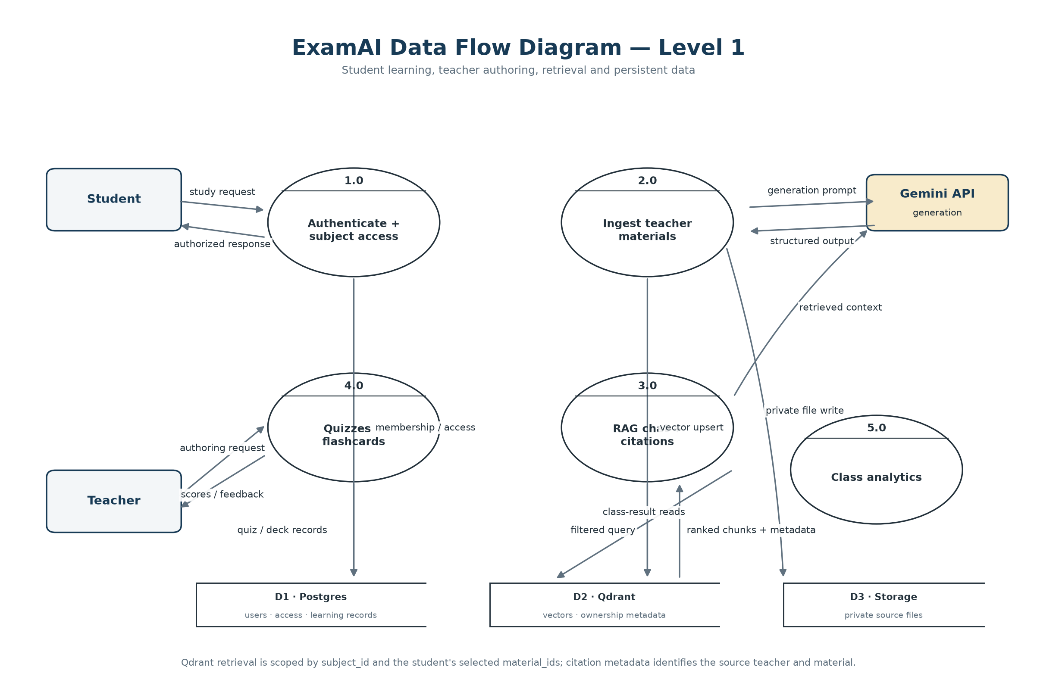
Figure 7.6.2: Level 1 DFD
7.7 Data Model
The relational model contains users, subjects, subject–teacher membership, student–subject enrollment, materials, quizzes, quiz questions, quiz attempts, flashcard decks, and flashcards. A material belongs to one teacher and one subject; a subject may have multiple teachers. A quiz is teacher-authored and subject-scoped; an attempt belongs to one student and one quiz. A flashcard deck belongs to one student and records its source material identifiers. The per-session material selection is intentionally request-time data, not a table — this keeps "adjustable per session" true at the data layer.

ExamAI was built, tested, and verified end to end as a local prototype: every feature described in the earlier chapters works as designed against the offline test suites (82 backend, 63 frontend) plus manual end-to-end passes over a local run. This chapter walks through the finished screens in the order a user meets them, with a short discussion of each one. (Online deployment is planned but not yet carried out, so all screens below are captured from the local build running against seeded demo accounts — the names visible are seed data, not real users.)
8.1 Login and Role-Based Access
A provisioned user logs in with email and password; the backend derives the role from the stored profile and the frontend routes to the student or teacher workspace accordingly. The sign-in form offers email and password fields only — there is no signup link and no client-side role selector, so an unregistered email is rejected and an authenticated user can never reach the other role's routes.
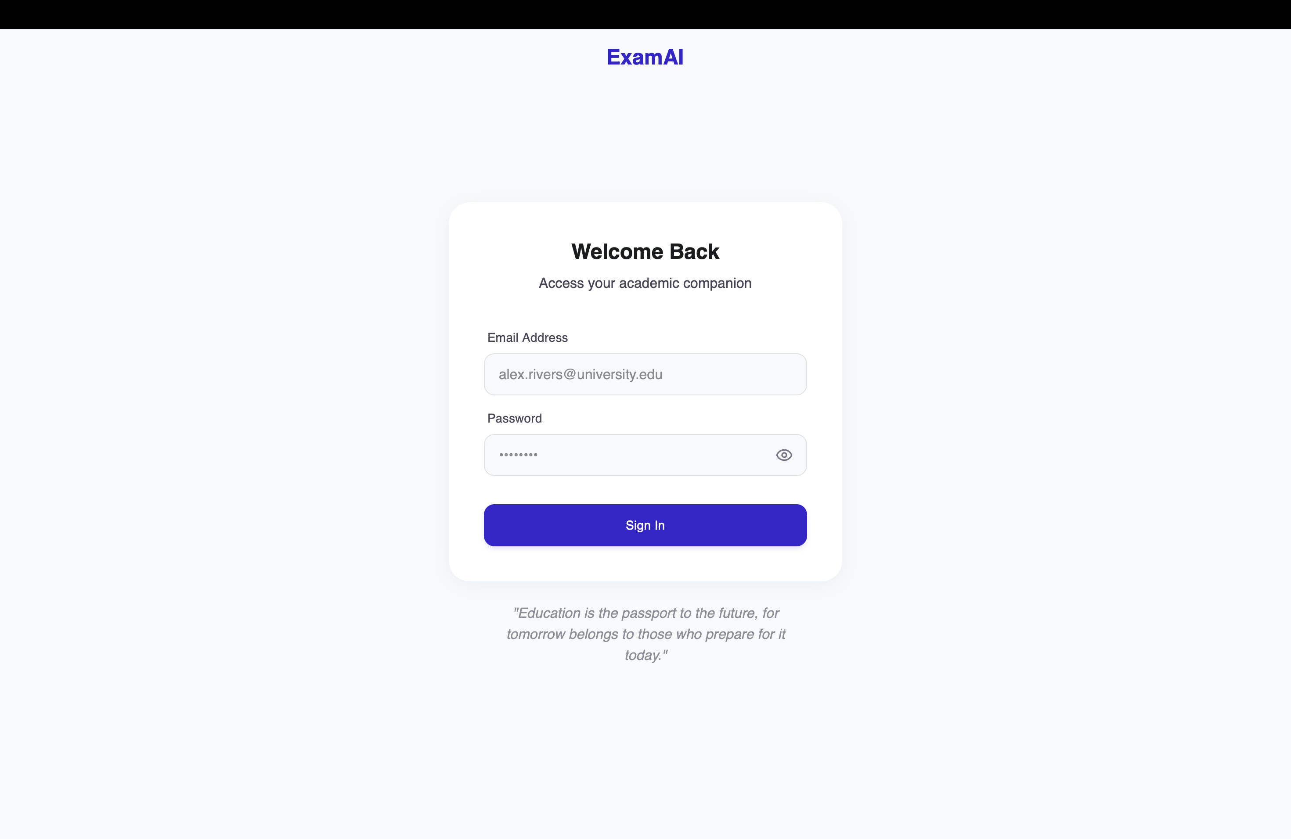
Figure 8.1: Sign-in form — email and password only, no signup or role selector.
8.2 Student Dashboard and Subject View
The student home opens with a study hero panel leading into chat, followed by quick stats (quizzes taken, weak topics, average score) and enrolled-subject cards showing each subject's teachers and the student's progress. The demo account in Figure 8.2 shows three enrolled subjects — including multi-teacher subjects — with per-subject progress bars. The Resources view (Figure 8.3) states the ownership promise directly — "Materials approved by your teachers, grouped by course" — with browse-by-course pills, filter-by-teacher checkboxes, a Recently Added strip, and an All Materials table (name, course, date, size, owner). Only `ready` materials appear in this student-facing list; processing or failed items remain a teacher-side concern.
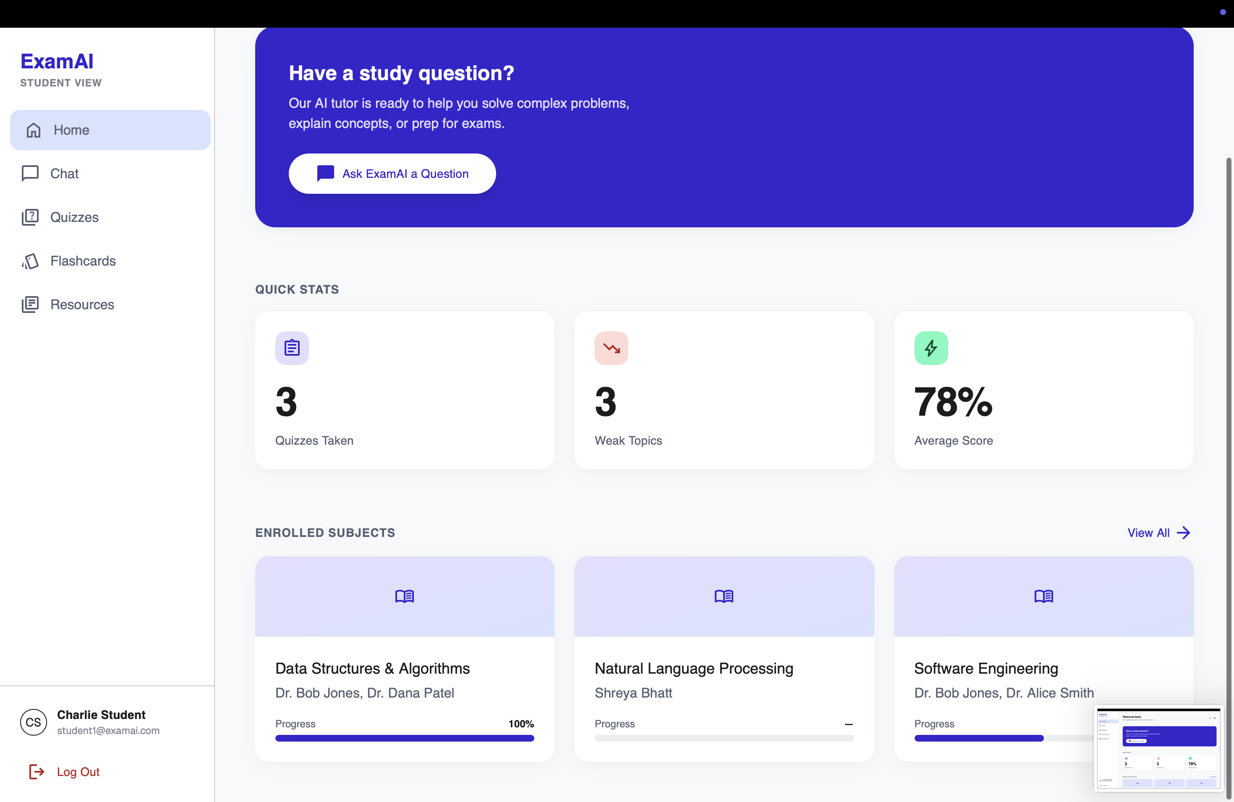
Figure 8.2: Student dashboard — study hero, quick stats, and enrolled subjects with teachers and progress.
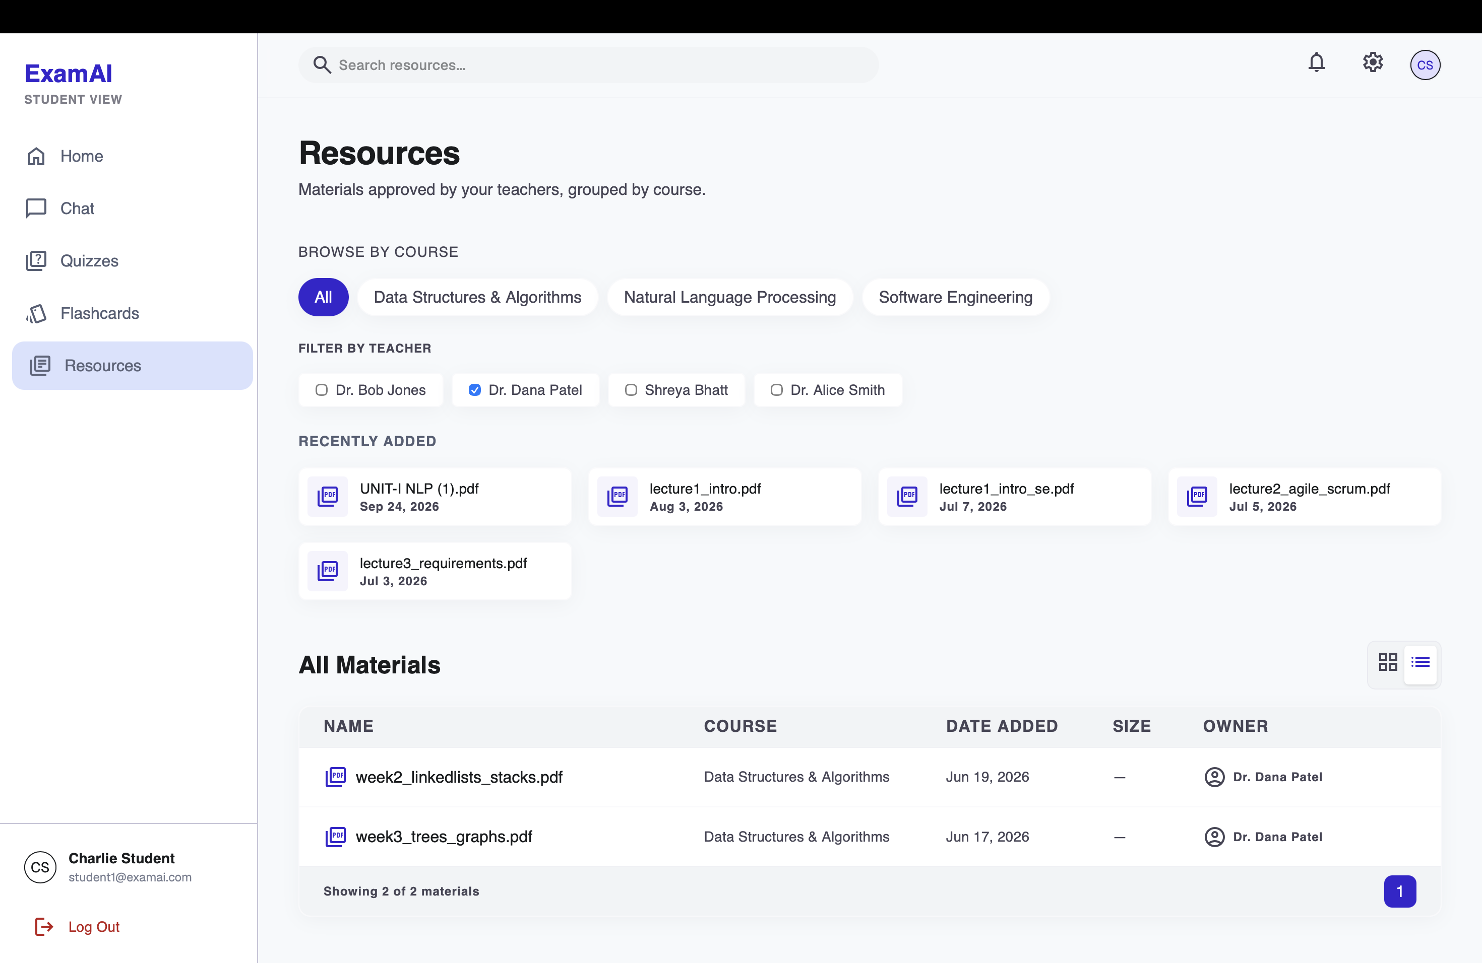
Figure 8.3: Subject resources — approved materials grouped by teacher with filter; only ready items are visible to students.
8.3 RAG Chat with Material Scope and Citations
The chat view pairs the conversation with a visible study-materials panel: the student ticks which ready materials should ground the session (grouped under the owning teacher's name), with the active count always shown. Answers render with numbered citation markers; hovering a marker reveals the teacher and filename, and a citation footer under each answer names the source explicitly. Figure 8.4 demonstrates both halves of the attribution guarantee: the in-corpus question ("What is NLP") receives a grounded answer citing the teacher's file, while the off-corpus question ("who is Donald trump") is refused with "The provided context is insufficient…" instead of hallucinated — the system answers only from approved material.
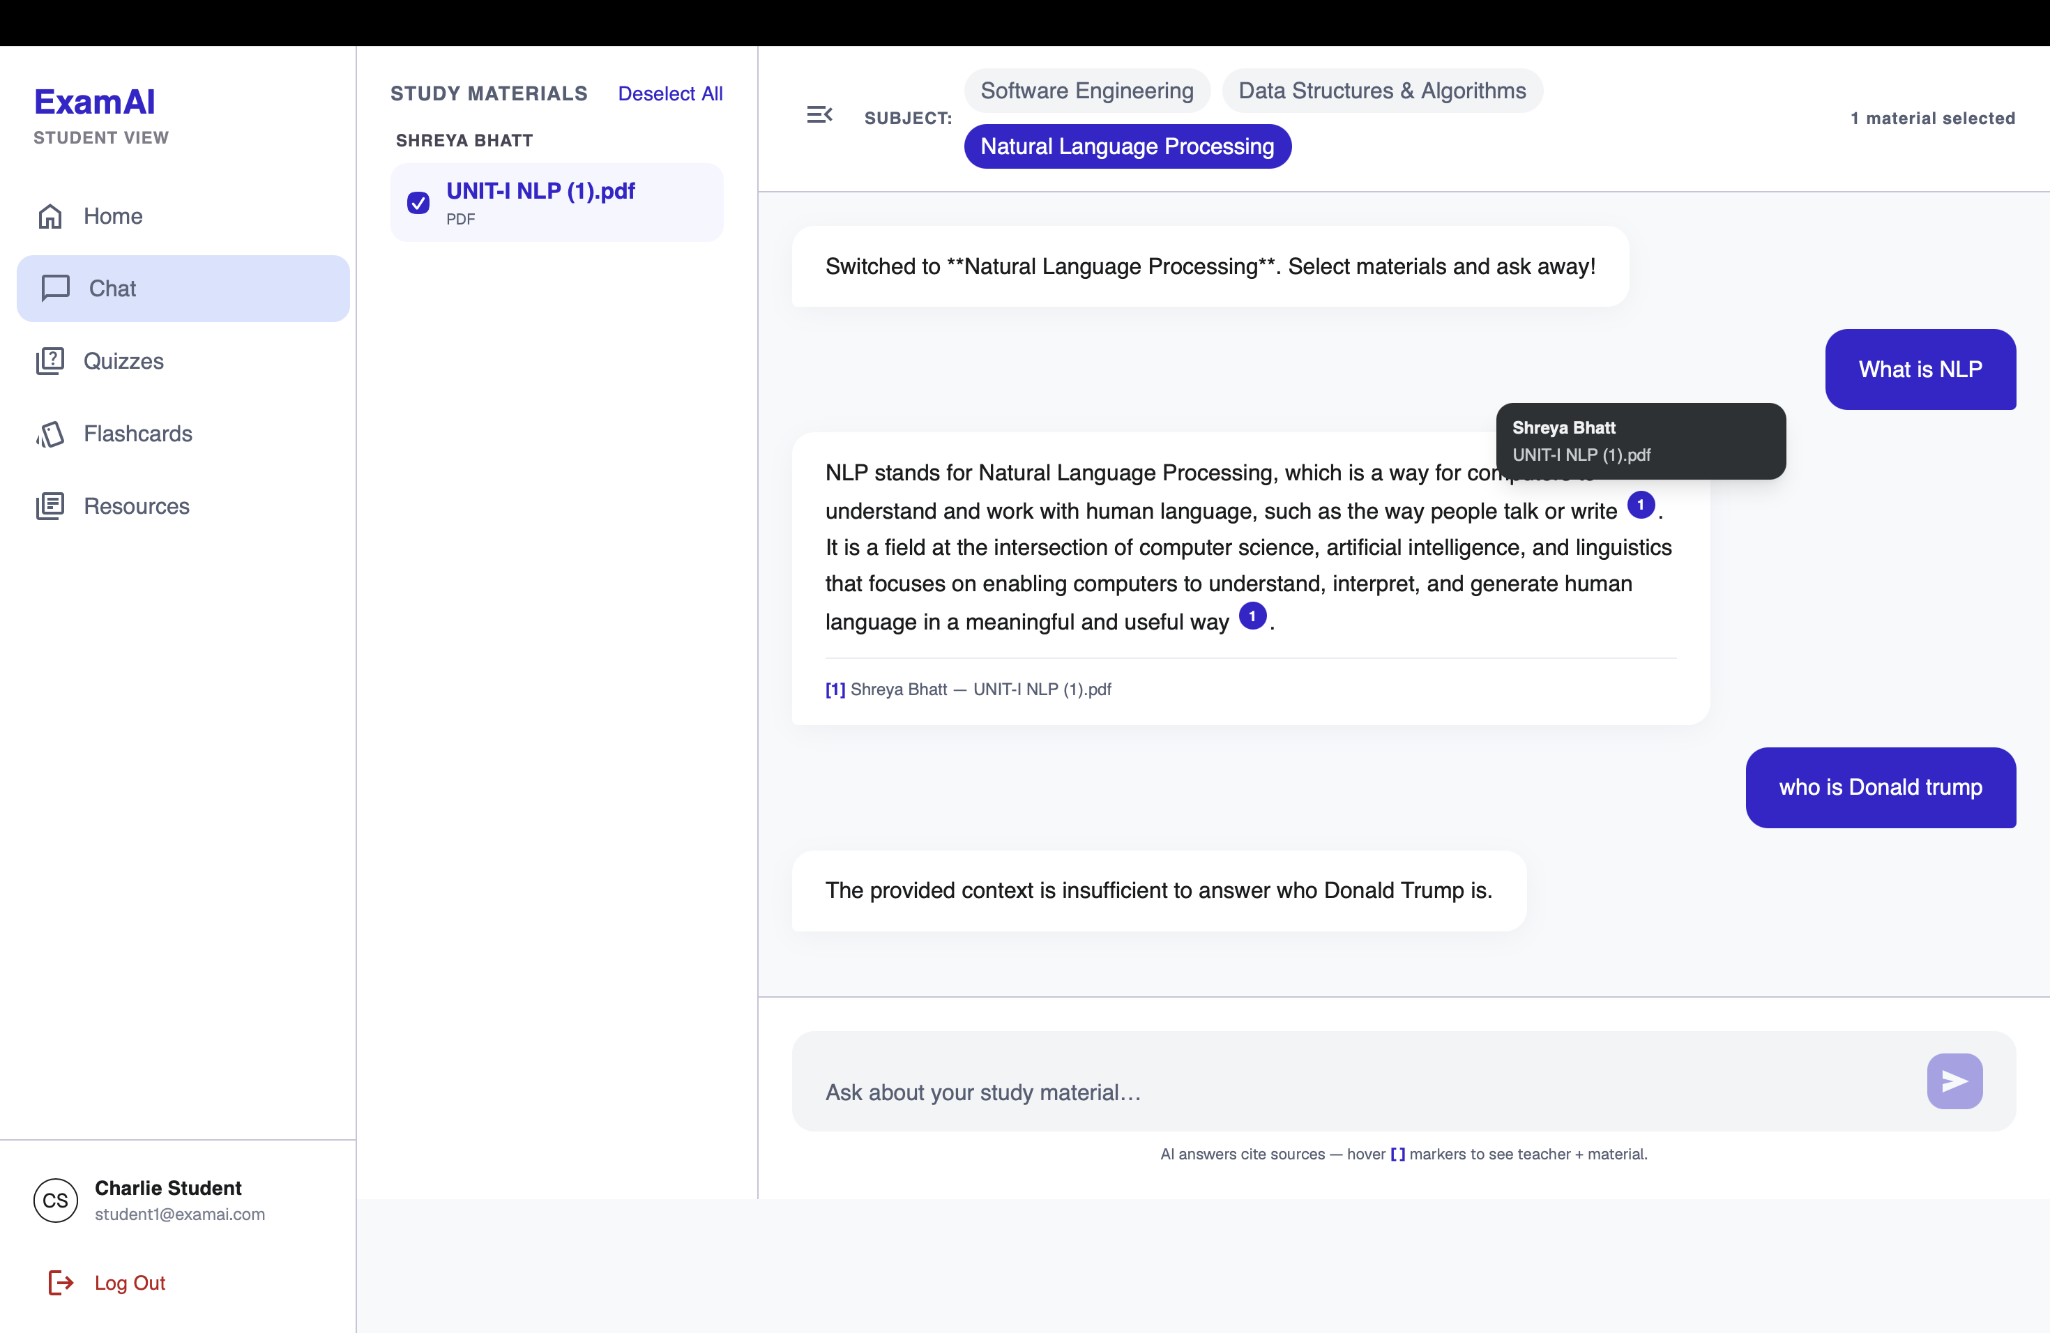
Figure 8.4: RAG chat — per-session material scope, numbered citations with teacher/file tooltip, and grounded refusal of an off-corpus question.
8.4 Quiz Taking and Feedback
The quiz list (Figure 8.5) shows four published quizzes across the student's subjects, each naming its authoring teacher: completed ones carry a Completed badge with the score and a View Results action, while the unattempted one offers Start Quiz. Taking a quiz (Figure 8.6) presents one question at a time under a visible countdown timer with Previous/Next navigation and progress dots. On submission the server grades the attempt and returns a grade card (Figure 8.7 shows a D at 50%, 3 of 6 correct) with an "Areas to Review" breakdown by topic tag (SDLC 67%, Requirements 33%), followed by a full question review (Figure 8.8) marking each response — the student's wrong pick highlighted in red against the correct choice in green, as seen in Q2 where the chosen distractor and the correct answer are shown side by side. Re-submitting an attempt is idempotent — the score is not duplicated.
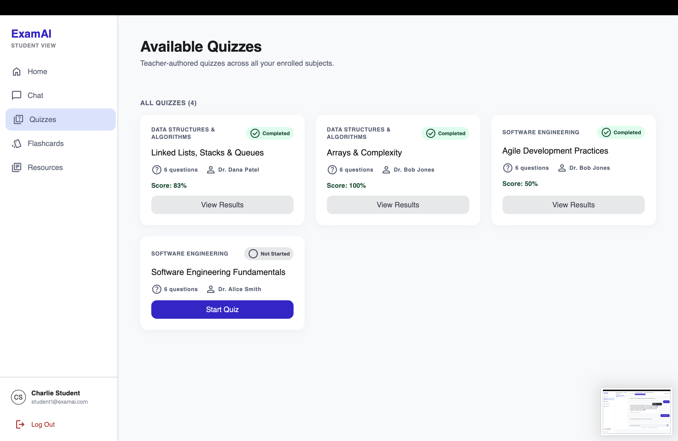
Figure 8.5: Published quiz list with completed scores.
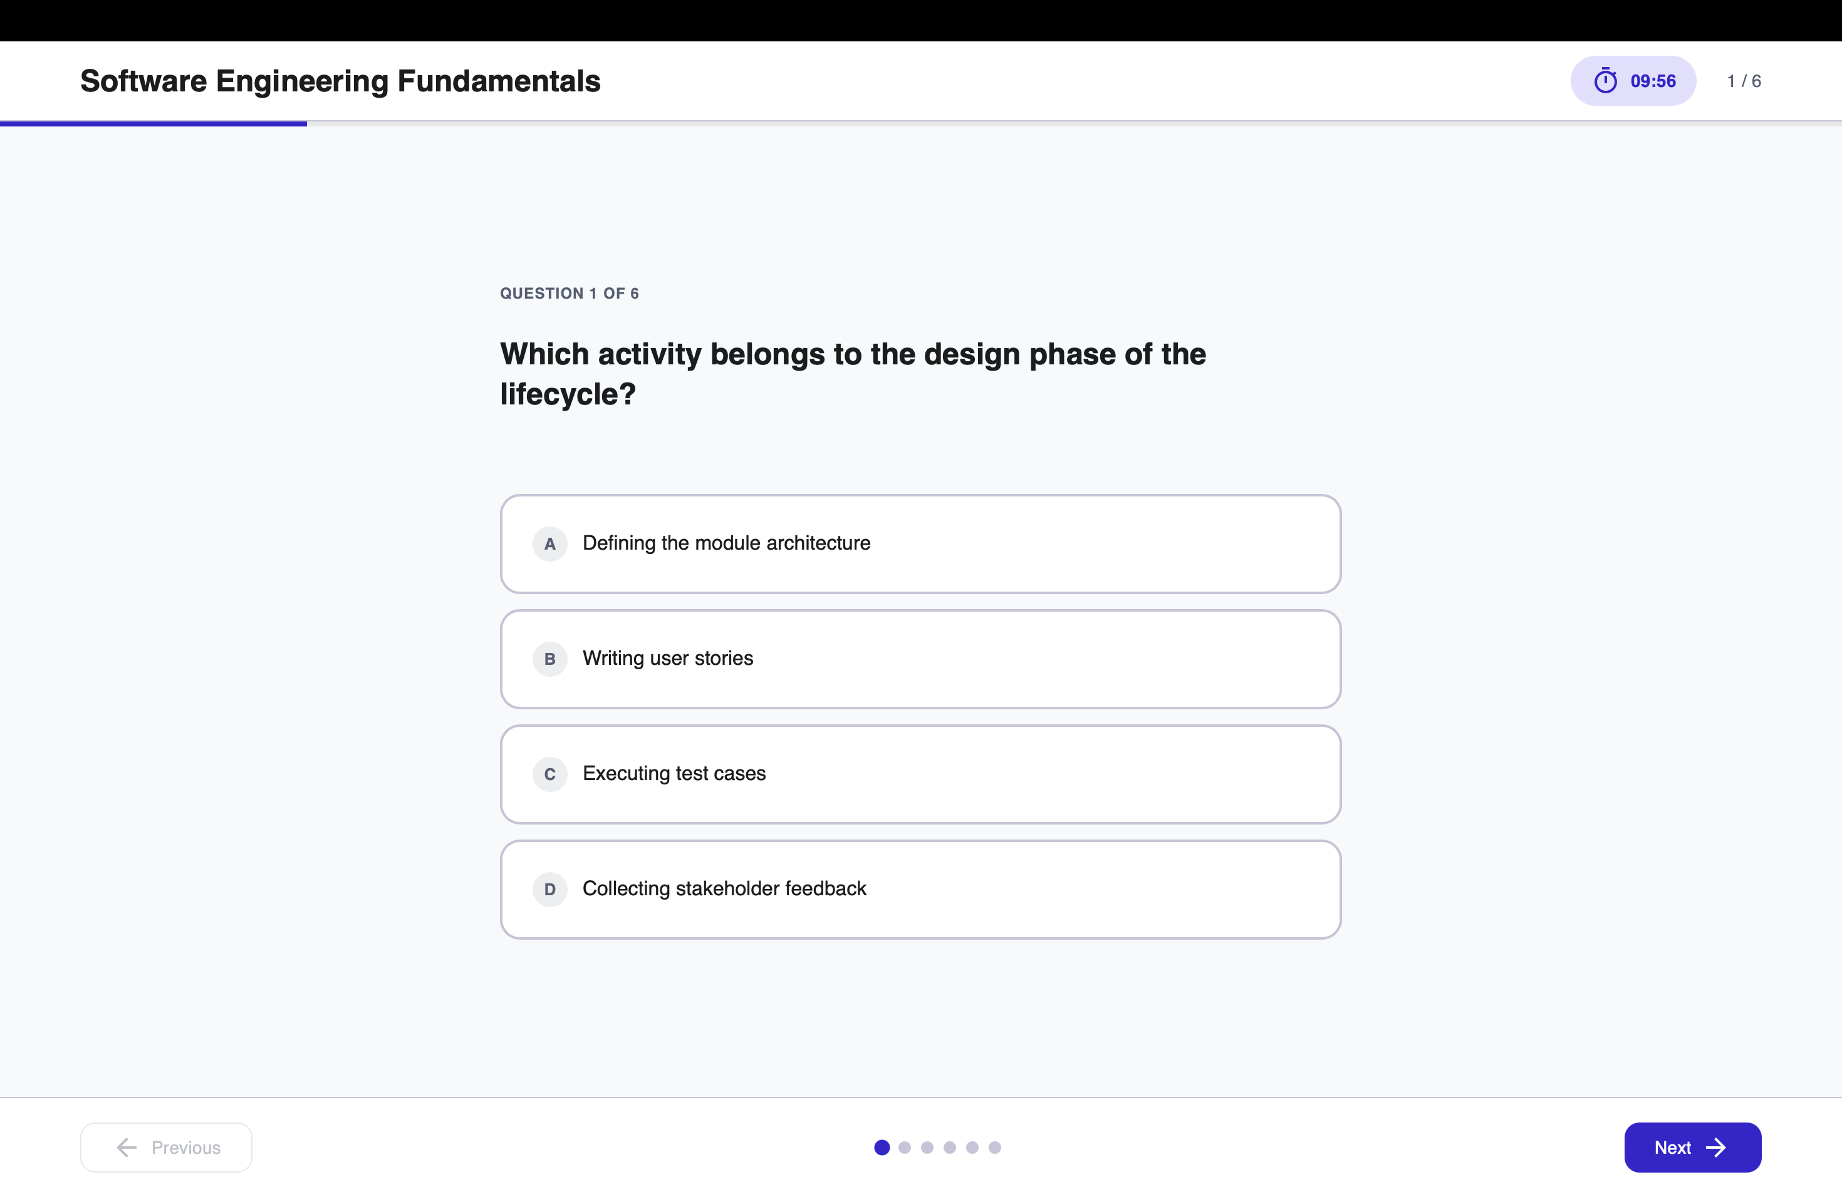
Figure 8.6: Quiz taking — one question at a time under a visible countdown with Previous/Next navigation.
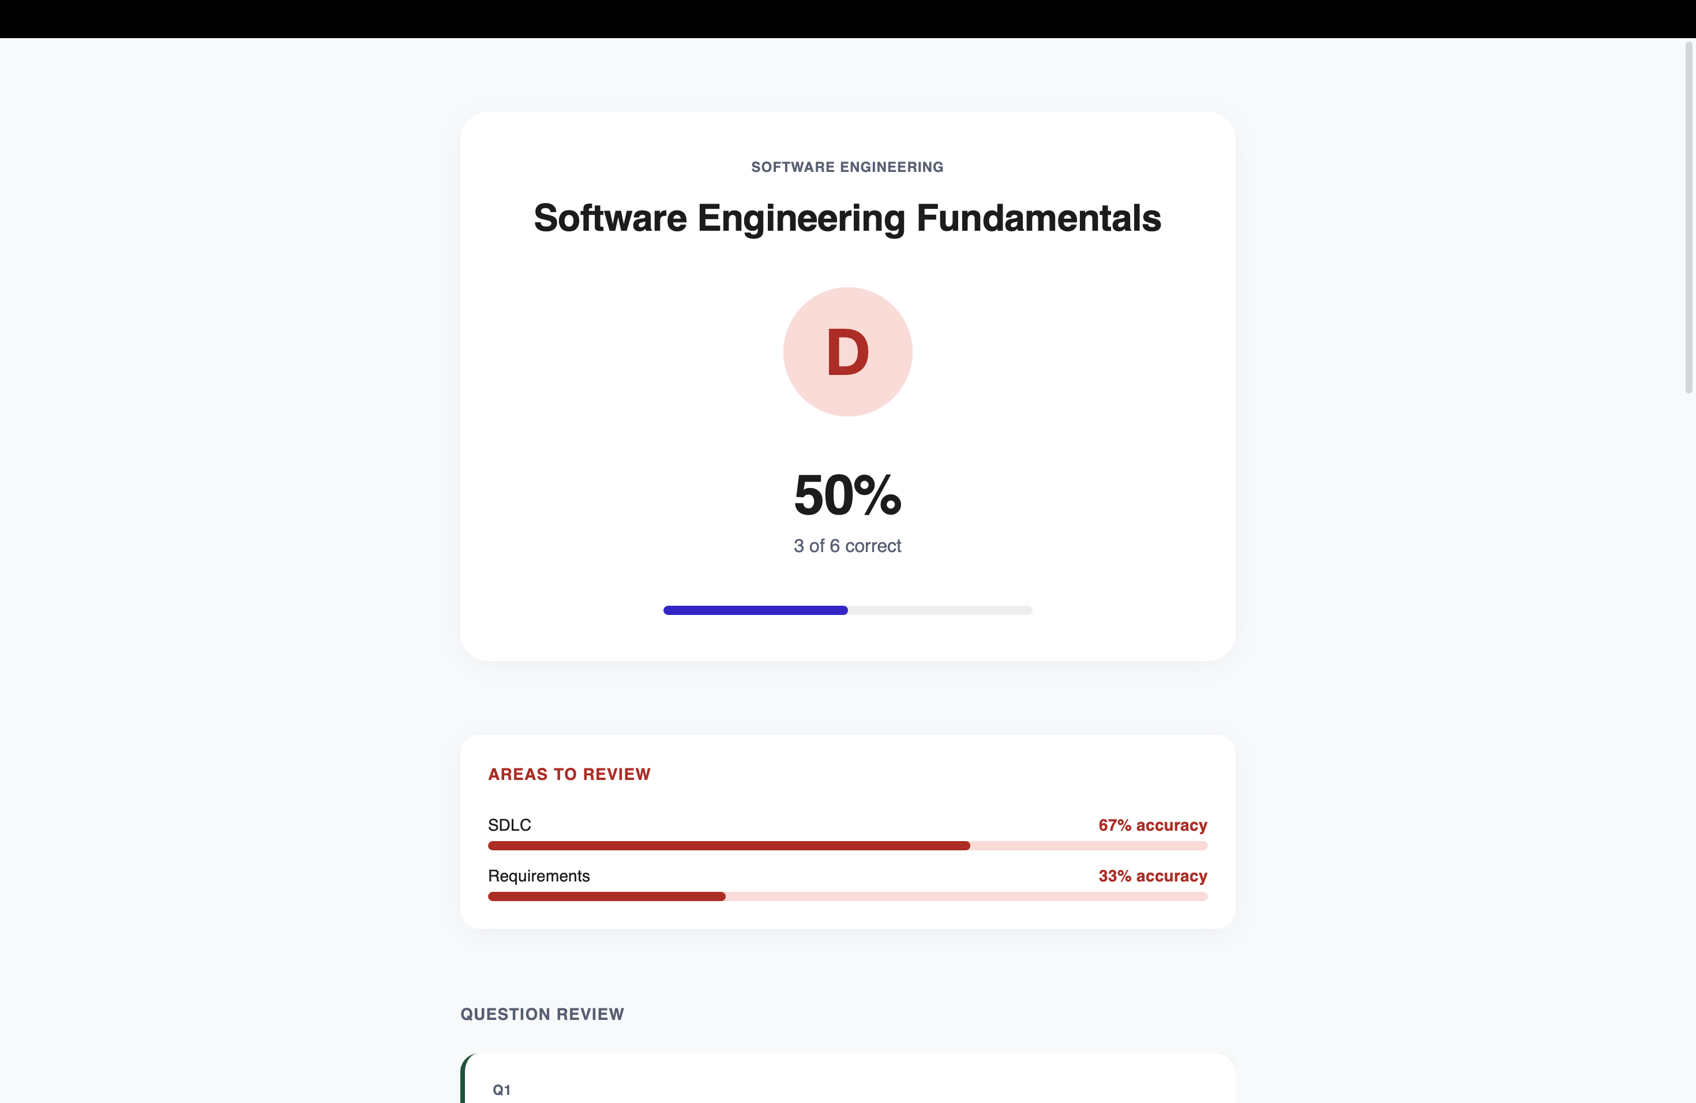
Figure 8.7: Result card — grade, score, and per-topic areas to review.
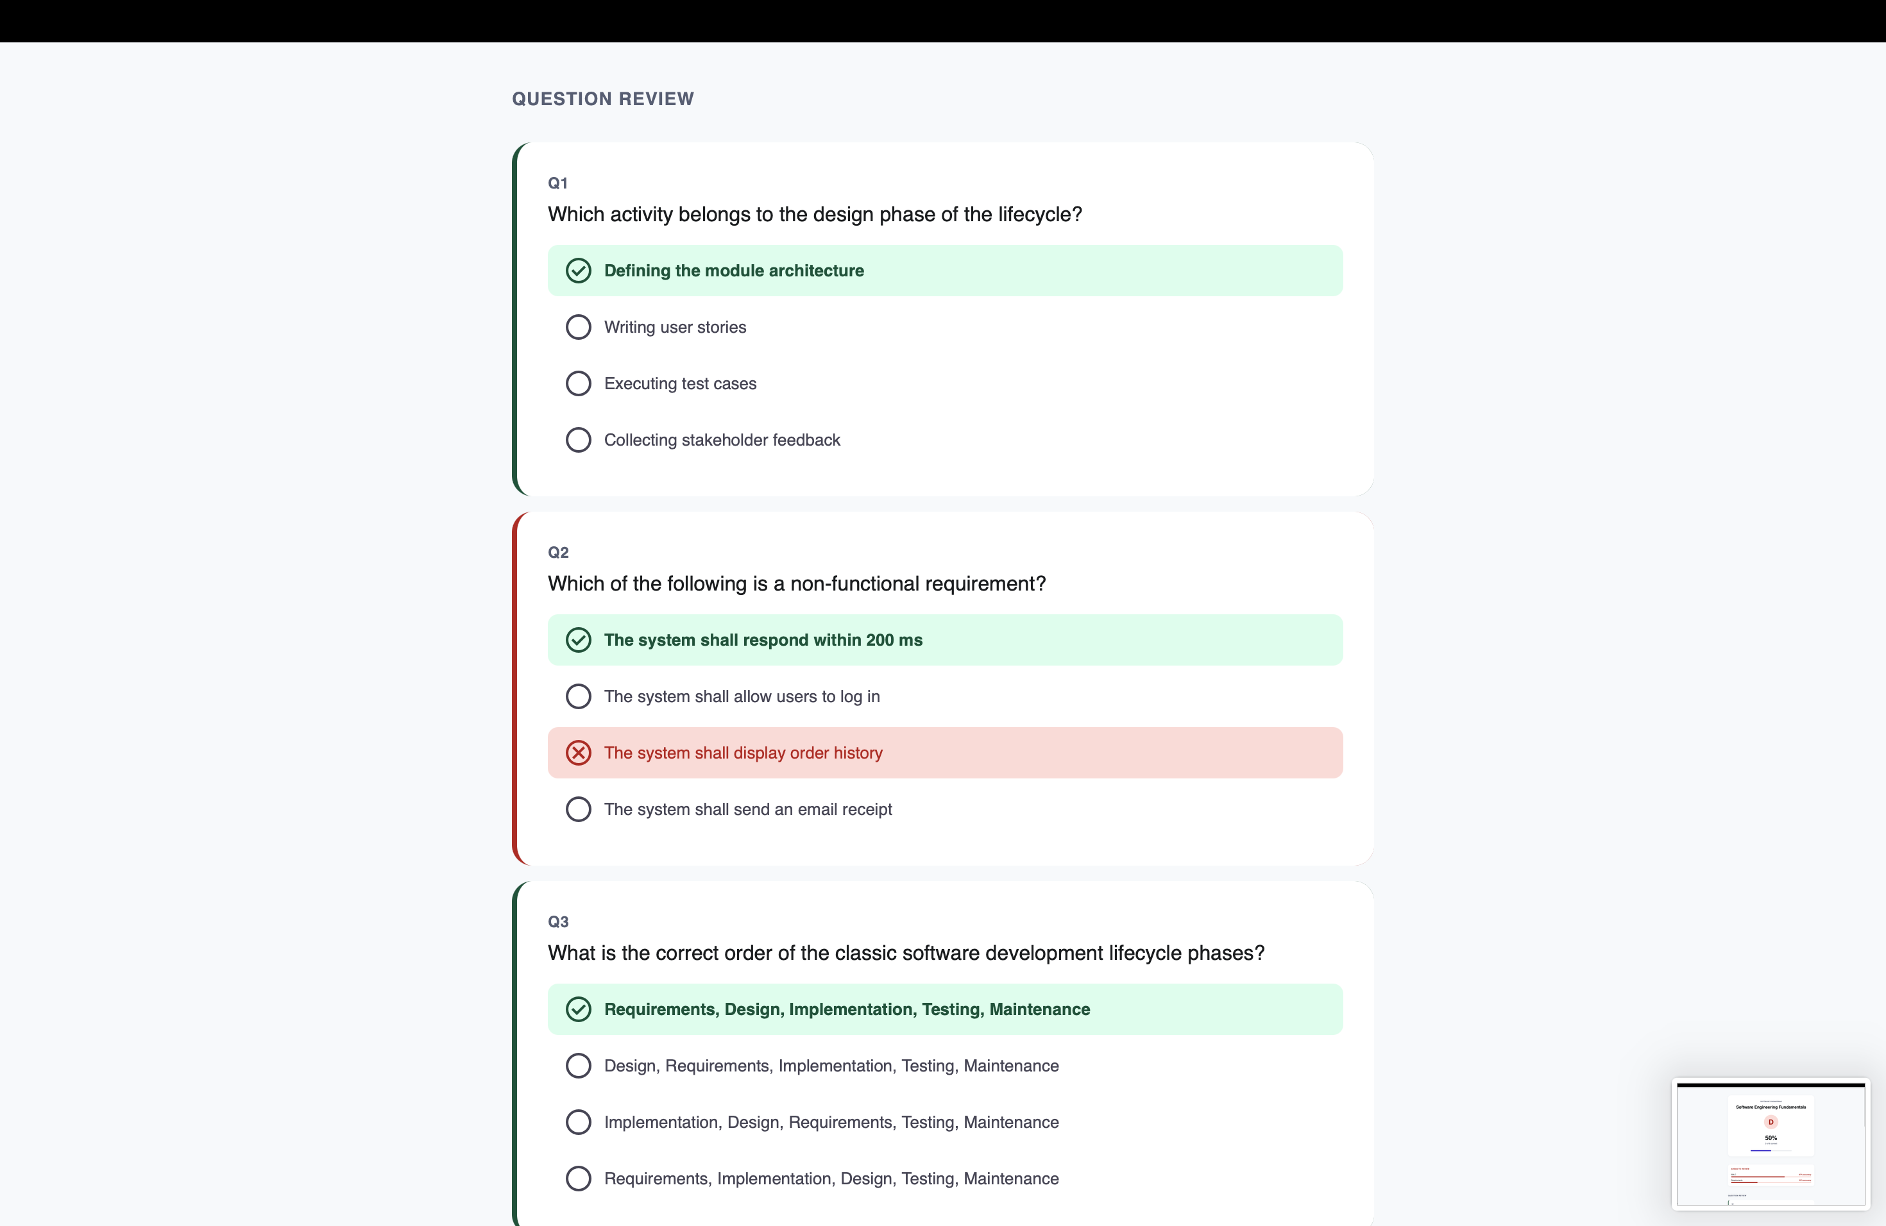
Figure 8.8: Question review — per-question correct/wrong marking against the correct choice.
8.5 Flashcard Generation and Study
From any selected material set the student generates a named deck via the Generate New Deck action; the deck list (Figure 8.9) shows two personal decks with card counts, mastered counts, and mastery bars (8 cards / 4 mastered / 50%; 10 cards / 3 mastered / 30%). Cards are studied in a flip view (Figure 8.10 shows card 1 of 8 in "Data Structures Quick Cards" with tap-to-reveal) and marked still-learning or mastered, moving the card between `new`, `learning`, and `mastered` states. Decks are personal to the student and record the source material identifiers used at generation, so a deck can always be traced back to what it was built from.
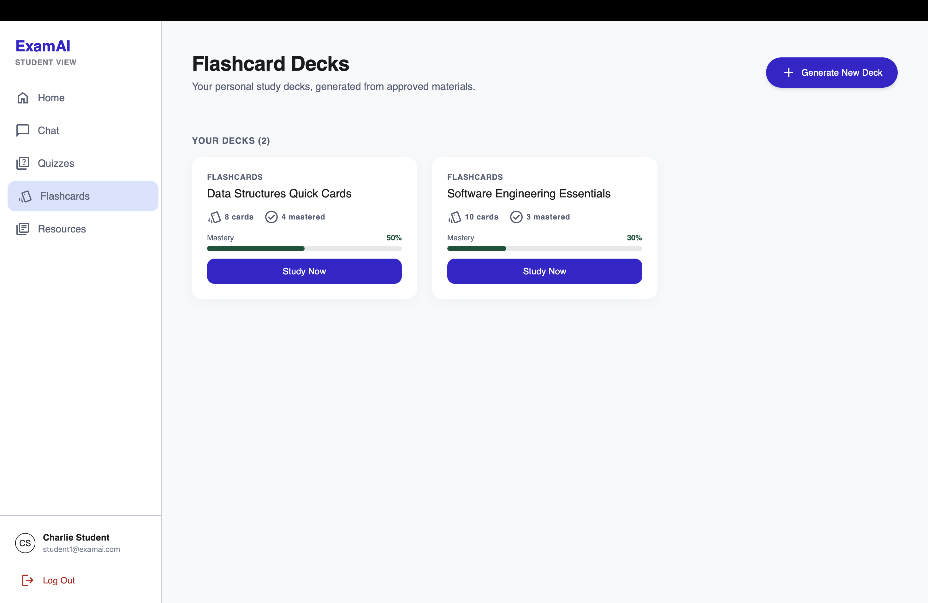
Figure 8.9: Flashcard deck list with mastery progress.
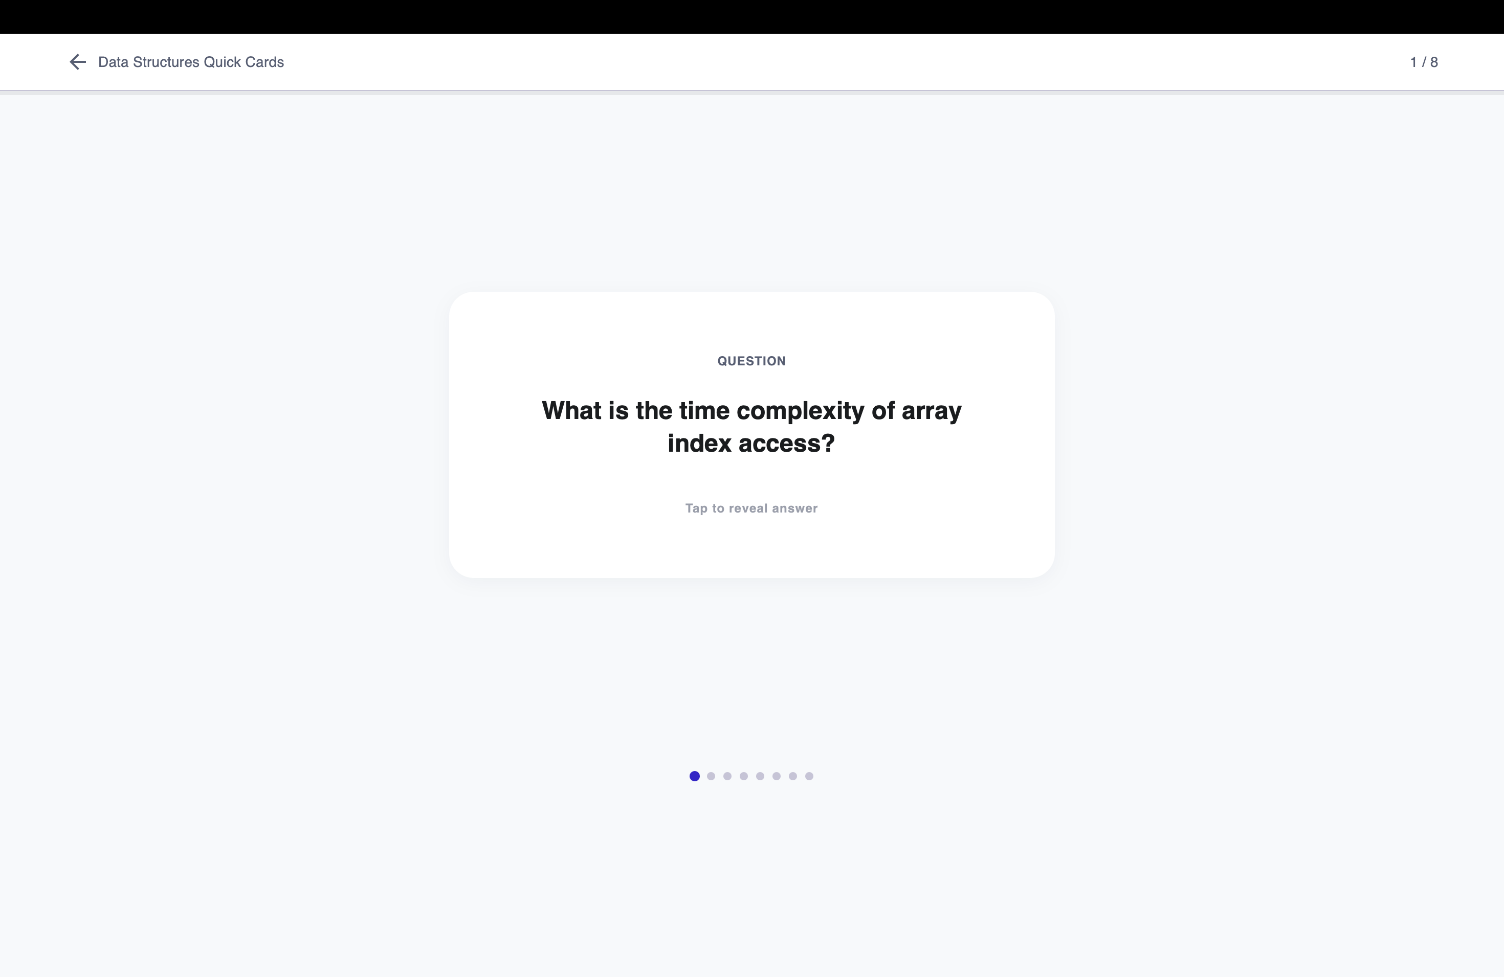
Figure 8.10: Flip-study view — question front with answer reveal and mastery controls.
8.6 Teacher Material Management
The teacher materials view ("Resources & Materials") states its sharing rule directly: "Co-teacher materials are visible but read-only." A drag-and-drop upload zone accepts PDF, PPTX, and DOCX with per-subject tabs, and the All Materials table lists file, subject, owner, status, and upload date. The Owner column distinguishes the teacher's own files ("You", editable) from a co-teacher's (visible only), and the captured rows show Ready badges — the `processing` and `failed` states with retry, plus deletion, are handled by the same pipeline (Section 7.5) and covered in testing (Chapter 6).
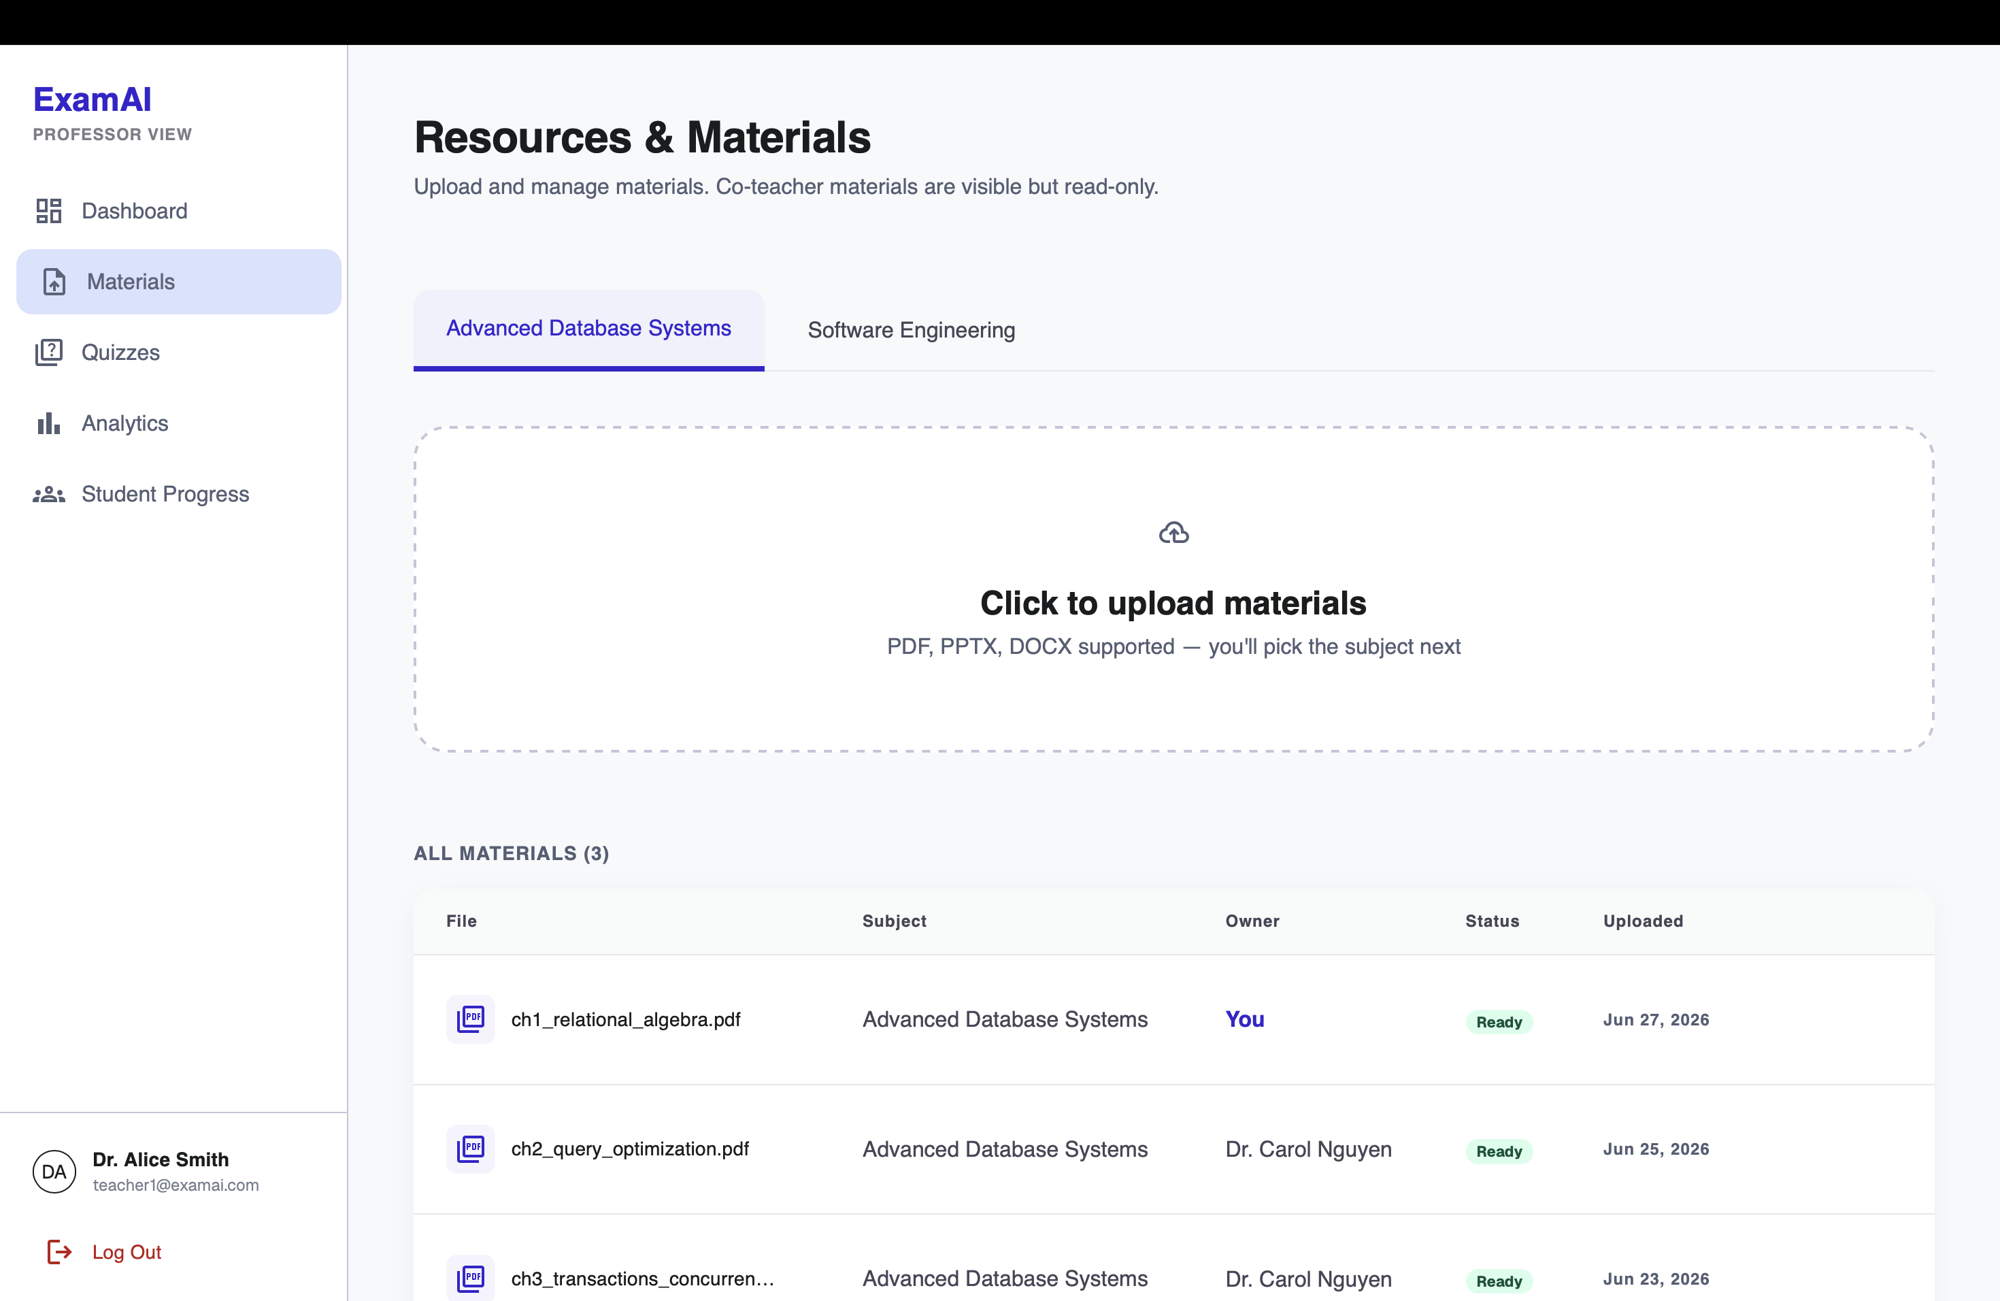
Figure 8.11: Teacher materials — upload dropzone, subject tabs, owner column separating own vs co-teacher files, Ready status badges.
8.7 Teacher Quiz Authoring and Publishing
The quiz list states the fairness rule directly: "All students in a subject take the same published quiz." Each card carries a Draft/Published badge and a Manual/AI source tag, with Edit, Publish, and delete actions — drafts expose a Publish button while published quizzes do not. Teachers author manually question by question, or request an AI-assisted draft generated from ready material; both paths produce the same question shape, and AI drafts remain drafts until reviewed and published.
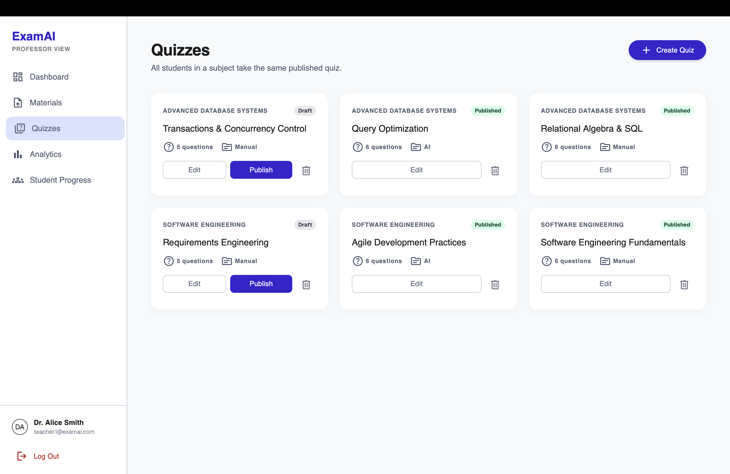
Figure 8.12: Teacher quiz list — draft/published badges, manual/AI source tags, publish flow.
8.8 Teacher Analytics and Student Progress
The analytics design deliberately separates per-quiz analysis from cross-quiz student progress. The per-quiz view (Figure 8.13, captured on a 17-student class with 16/17 completion and a 79% average) shows a question-accuracy heatmap with a Good/OK/Weak/Poor key, an A–F grade distribution, and the derived weak topic ("Indexing" at 69% class accuracy) — answering "how did this quiz go?". The student progress roster (Figure 8.14) lists every student with average score, completion bar, last-active date, and an At Risk / On Track badge, with a "7 at-risk" summary counter, name search, and subject filter on top and a drill-down chevron per row — answering "how is this student doing?". The teacher dashboard (Figure 8.15) adds an at-a-glance overview: active students, subject materials, quizzes created, and average section score (22 / 7 / 6 / 70% in the capture), with a recent-activity feed of who completed which quiz at what score, a grade-distribution summary, and an AI-insights card. Keeping these read models separate avoids forcing two different questions into one overloaded query.
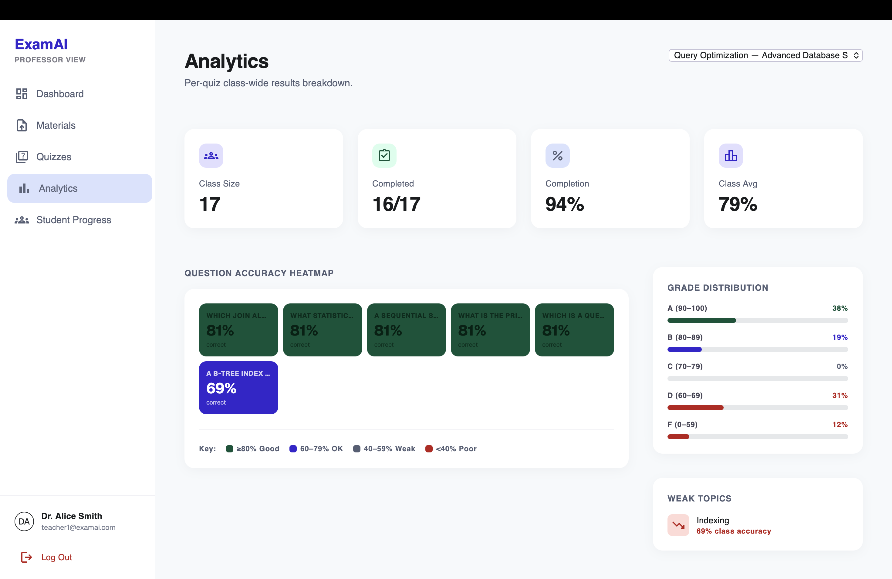
Figure 8.13: Per-quiz analytics — class stats, accuracy heatmap, grade distribution, weak topics.
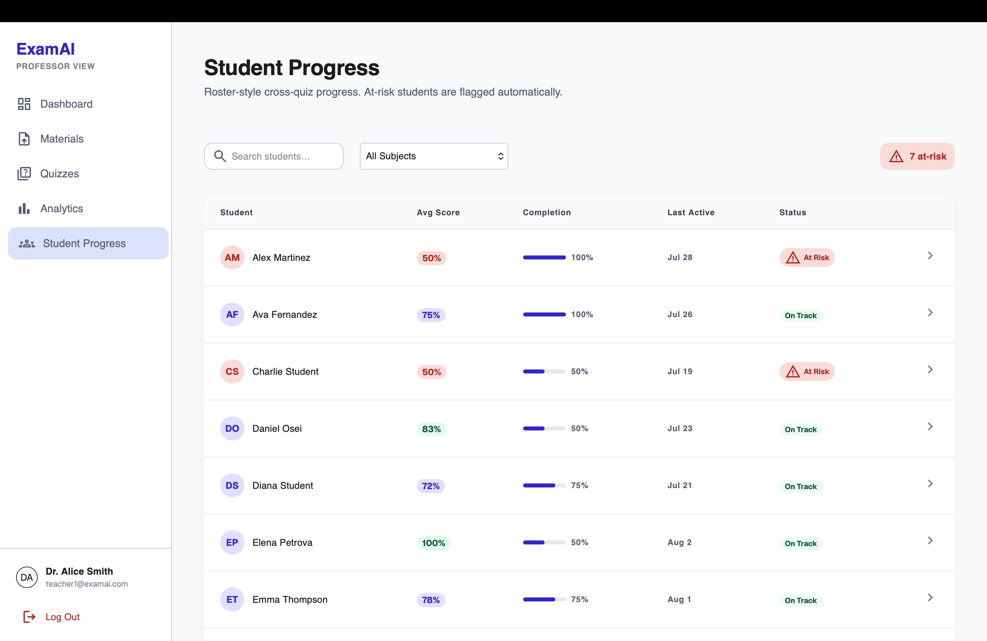
Figure 8.14: Student progress roster — averages, completion, at-risk flags with drill-down.
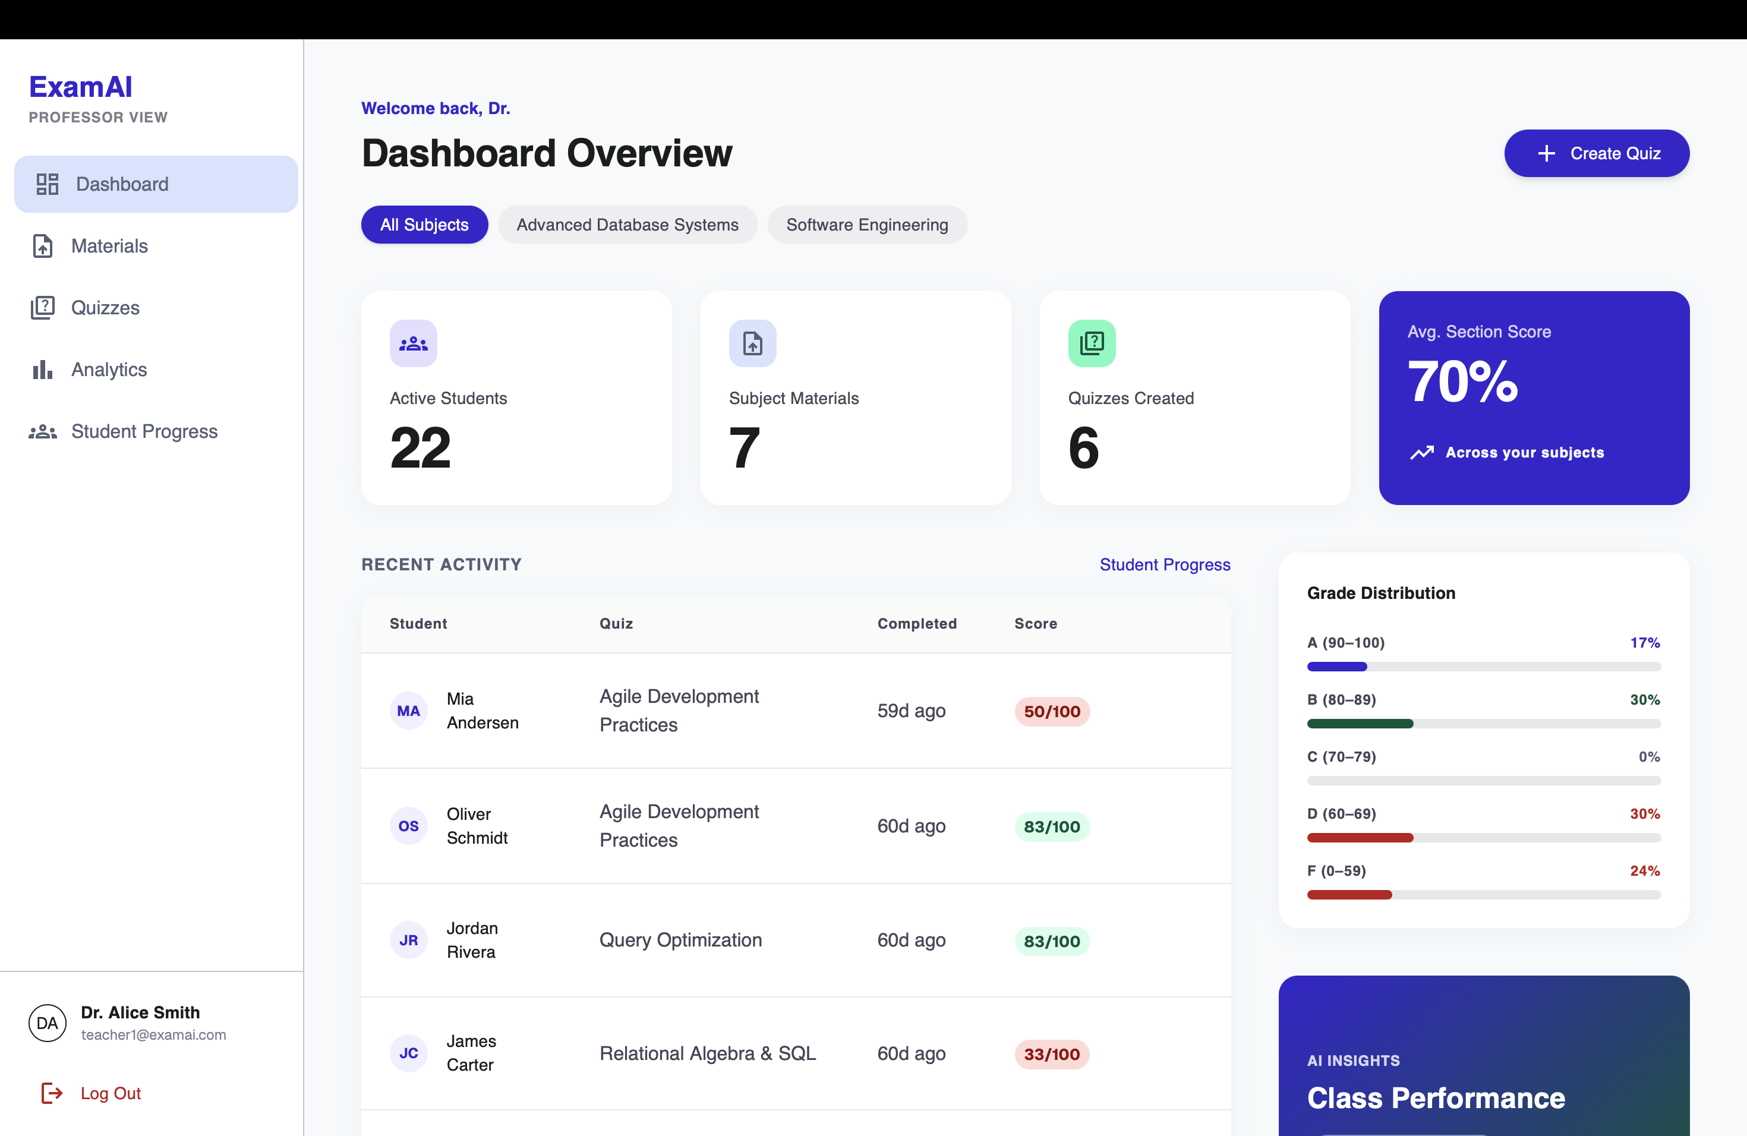
Figure 8.15: Teacher dashboard overview — activity stats, recent completions, grade distribution, AI insights.
8.9 Security and Reliability Results
Access tokens are kept in memory with a HttpOnly refresh cookie; the API client performs one silent refresh-and-replay after a 401 before redirecting to login. CORS uses an allow-list and storage paths are never serialized to clients. Authorization checks are repeated in services rather than relying on route declarations alone. The ingestion pipeline uses per-material locks, row-level guards, and version-safe updates, with blocking parser and embedding calls moved off the event loop. Structured generation uses Pydantic schemas as the output contract, retrying with the error, the bad response, and the schema on failure. These patterns improve reliability without pretending external AI services are deterministic.
8.10 Overall System Performance
The backend suite (82 tests) runs fully offline in under a second; the frontend suite (63 tests) runs under Vitest with route, store, and component coverage. Frontend performance work includes route-level code splitting, navigation prefetching, bounded safe-GET caching, concurrent request deduplication, debounced search, loading skeletons, and stale-response handling — targeting measured responsiveness while preserving correctness. The known performance caveat is dependence on hosted services (database, vector store, model API) at deployment time: latency and quota there are deployment properties, and online hosting remains planned future work (Chapter 9).

9.1 Limitation
- ExamAI is a web application only — there is no mobile app yet.
- Users are provisioned by an explicit seed operation; there is no public signup, password reset, OAuth, or administrator role.
- The generated answer is limited by the quality and coverage of uploaded material. Source attribution identifies the retrieved passage but does not guarantee the model's interpretation is correct; teachers must review AI-assisted quizzes before publication.
- Retrieval is dense-vector only; sparse/keyword signals (exact terms, codes, formulae) are not separately indexed.
- Generation features depend on the configured Gemini model, quota, and billing, which must be verified per deployment.
- There is no in-app teacher–student messaging or broadcast, and no payment or purchase flow.
- Analytics describe quiz attempts within the application; they do not claim to measure long-term learning outcomes.
9.2 Future Enhancement
- Add hybrid dense-plus-sparse retrieval and compare retrieval quality on a controlled dataset.
- Add richer source previews (page/slide thumbnails) and material version history.
- Introduce student-generated personal practice quizzes as explicit v2 scope, kept separate from shared graded assessment.
- Add institutional identity integration, administrator controls, and deployment observability (logging, metrics, backups).
- Build mobile clients against the existing REST API without backend changes.
- Run accessibility audits and extend evaluation to citation correctness, quiz quality, and study outcomes.

10.1 Conclusion
ExamAI brings teacher-controlled study help, shared assessment, personal revision, and class-wide analytics together into a single role-aware platform — closing the three gaps found in existing systems during the literature survey in Chapter 2: unattributed answers, incomparable assessments, and scattered teacher oversight.
The project was built end to end — from a versioned relational data model and a metadata-preserving ingestion pipeline, through filtered retrieval and schema-guarded generation, to a responsive React interface with teacher dashboards — and is verified by 82 offline backend tests and 63 frontend tests plus manual end-to-end passes. Building it strengthened practical skills in full-stack architecture, authorization design, retrieval systems, working with non-deterministic AI components, and keeping academic comparability intact while adding AI assistance.
While the current version has known limitations, listed clearly in Chapter 9 rather than left to be discovered later, the platform already delivers on its core goal: a student always knows which teacher's material — and which page — an answer came from, and a teacher always sees how the whole class performed on the same questions.

11.1 Business Model
ExamAI is currently built and presented as an academic project rather than a commercial product. If extended toward institutional use, it would naturally fit a department-level service model — the platform hosted for a department or coaching organization with teacher-managed subjects, private file storage, and usage-based AI limits. Any such model would require clear privacy, data-retention, accessibility, and service-cost policies. The current report makes no commercial deployment claim.
11.2 Product Deployment Detail
For local development, the backend runs from the `backend/` directory with Python 3.14 and its canonical virtual environment; migrations apply via Alembic, demo data seeds through the project seed command, and the FastAPI service exposes its API and documentation. The frontend starts with Vite and targets the configured API base URL.
Component | Hosting | Role
Frontend | Static build (Vite output) | Serves the React application to users
Backend | Render.com (FastAPI via Uvicorn) | Serves the REST API
Database/Auth/Storage | Supabase (managed Postgres) | Users, subjects, materials, quizzes, attempts, decks; private files
Vector search | Qdrant Cloud (single collection) | Embedded material chunks with filterable payloads
Generation | Gemini API | Structured chat, quiz, and flashcard generation

Online deployment is planned but not yet carried out; the current delivery is a verified local prototype with a defined production layout as tabulated above.
11.3 API and Web Service Details
ExamAI exposes its functionality through a RESTful API built with FastAPI. Every endpoint is documented automatically and can be explored interactively at `/docs` on the backend. Responses use a standardized envelope with request identification.
Method | Endpoint | Description
POST | /api/auth/login | Log in a provisioned user; role derived from profile
GET | /api/subjects | List accessible subjects for the current role
POST | /api/materials | Teacher upload of PDF/PPTX/DOCX with status tracking
POST | /api/chat | Ask a question over subject + selected material IDs
GET/POST | /api/quizzes | List / create (manual or AI-assisted) quizzes; publish flow
POST | /api/quizzes/{id}/attempts | Submit an attempt; server-side grading with weak topics
GET/POST | /api/flashcards/decks | List / generate personal decks; mastery updates
GET | /api/analytics/quiz/{id} | Per-quiz heatmap, distribution, weak topics
GET | /api/analytics/progress | Cross-quiz roster with at-risk flags

Authentication is session/token based: the access token is kept in memory on the client with a HttpOnly refresh cookie, and every subject-scoped call re-checks enrollment or membership in the service layer.

BIBLIOGRAPHY
1. Moodle Project — Moodle LMS documentation, https://docs.moodle.org/
2. Google — Google Classroom Help, https://support.google.com/edu/classroom/
3. Quizlet — Flashcards and study tools, https://quizlet.com/
4. OpenAI — ChatGPT (reviewed as the representative general-purpose LLM chatbot for the literature survey, Chapter 2).
5. Google — NotebookLM (reviewed as the closest retrieval-grounded study assistant, Chapter 2).
6. FastAPI Documentation — https://fastapi.tiangolo.com/
7. SQLAlchemy Documentation — https://docs.sqlalchemy.org/
8. Alembic Documentation — https://alembic.sqlalchemy.org/
9. React Documentation — https://react.dev/
10. Vite Documentation — https://vite.dev/
11. Tailwind CSS Documentation — https://tailwindcss.com/docs
12. Qdrant Documentation — https://qdrant.tech/documentation/
13. Supabase Documentation — https://supabase.com/docs
14. Google AI for Developers — Gemini API documentation, https://ai.google.dev/gemini-api/docs
15. Hugging Face — Sentence Transformers documentation, https://www.sbert.net/

